Functional Requirements Document (FRD)
Maitribodh Access Management System (MAMS)
Item | Value
Document | Functional Requirements Document
Date | 13 October 2026
Scope | Phase 1 (MVP) for one Ashram; English only; responsive web application

Contents
1. Purpose
2. System Overview
3. User Roles and Access Control (RBAC)
4. Master Data Management
5. User Management Module
6. Person Registration Module
7. Staff Registration
8. Parivar Member Registration
9. Visitor Registration
10. Vendor Registration
11. Contractor Registration
12. Participant Registration
13. Registration Search Module
14. Approval Module
15. QR Management Module
16. Public QR Download Module
17. Gate Verification Module
18. Check-In Module
19. Check-Out Module
20. Occupancy Module
21. Blacklist Module
22. Reports Module
23. Notification Requirements
24. Audit Log Module
25. Error Messages
26. Complete Business Flow
27. Assumptions
28. Technical, Security and Data Protection Requirements

1. Purpose
The purpose of this document is to describe how the Maitribodh Access Management System will work from an end-user perspective. It defines screen-level behaviour, field rules and conditions that the development and testing teams build and verify.
This document explains:
- Functional requirements for every module
- Business validations and field rules
- User actions by role
- Screen behaviour and system messages
- Approval flows
- QR generation and the public QR download process
- Gate verification, check-in and check-out
- Occupancy, overstay, blacklist, reporting, notification and audit requirements

2. System Overview
The Maitribodh Access Management System (MAMS) is the single register of everyone who enters the Ashram. It will be used to:
- Register all persons entering the Ashram
- Bulk upload persons (permission-controlled)
- Generate a unique QR code for every Active registration, whether registered manually or through bulk upload
- Let a person download their QR from a public lookup page using the registered mobile number
- Verify persons at the gate by QR scan or mobile search
- Perform check-in and check-out across multiple gates with the gate and location recorded
- Assign locations to persons and manage open and restricted area access, enforced manually by Security
- Approve Staff and Parivar Members
- Block blacklisted persons
- Track occupancy and raise overstay alerts
- Generate reports and keep a complete audit trail
- Control access through four portal roles with a permission matrix underneath, enforced on the server (section 3)

2.1 Person and visit status models
Only Active persons can check in, and each person has at most one open visit. Blacklisting is a separate flag on the person, checked at every scan, so lifting it returns the person to the status they already held.
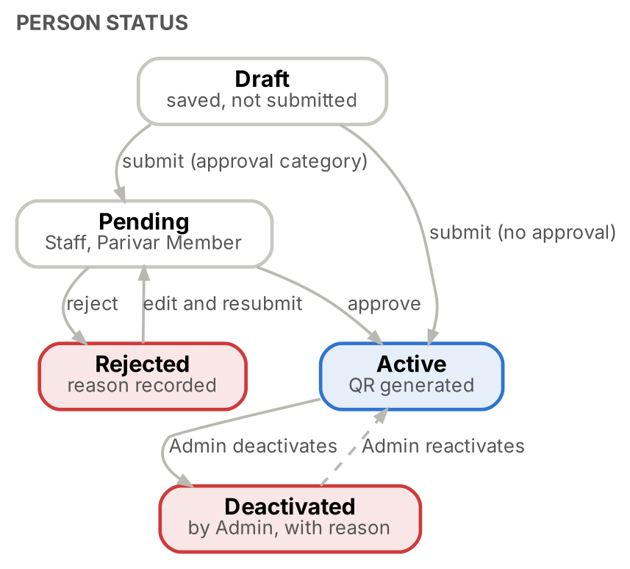
Figure 1. Person status lifecycle
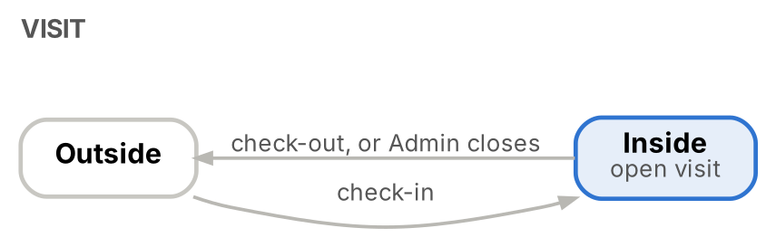
Figure 2. Visit lifecycle
Status | Meaning | Can check in?
Draft | Form saved but not submitted; visible only to its creator; resumable for 7 days; passport and ID numbers and uploaded files are not kept in the draft | No
Pending | Staff or Parivar Member waiting for approval | No
Active | Approved, or registered in a category that needs no approval; QR generated | Yes, if not blacklisted, access not expired and not already inside
Rejected | Approval refused with a reason; can be edited and resubmitted | No
Deactivated | Disabled by Admin or Super Admin with a mandatory reason (≤ 300 characters); only an Active person can be deactivated; can be reactivated with a reason | No

3. User Roles and Access Control (RBAC)
MAMS uses four roles with a permission matrix underneath them, rather than hard-coding every capability into role names. The role grants the baseline permission; the person’s category, record ownership, registration status and assigned gate constrain what the user can do (role-based plus attribute-based control). Permissions are enforced by the server on every request; the screen only hides what a role cannot use.

3.1 Role hierarchy and scope
Role | Purpose | Scope
Super Admin | Own the system, govern access and maintain accountability | Full system ownership and control
Admin | Run daily registration and access-management operations | Operational administration, registration and approvals (approval and configuration only when delegated)
Security Personnel | Verify identity and keep accurate entry and exit records at the gate | Gate verification, check-in and check-out, Visitor fallback registration
User (Visitor, Staff, Vendor, Contractor, Participant, Parivar Member) | Access personal registration information and retrieve their own QR | Personal QR retrieval and permitted self-service functions; never signs in to the portal

3.2 Super Admin
Type | Description
Permission | Create, modify and deactivate administrative accounts
Permission | Assign and revoke portal roles (the only role that can)
Permission | Configure person categories, departments, job roles and system settings
Permission | Register and manage any person category
Permission | Approve or reject pending registrations
Permission | Access all reports, audit records and check-in / check-out history
Permission | Manage blacklist entries and review security incidents
Permission | Edit records, and soft-delete records when justified and auditable
Restriction | No shared Super Admin accounts; strong authentication (MFA preferred, outside the MVP scope)
Restriction | Every privileged action is logged
Restriction | A reason is required for deletion, blacklist changes and sensitive permission changes
Restriction | Audit history cannot be deleted or altered through the normal interface

3.3 Admin
Type | Description
Permission | Register Visitors, Vendors, Contractors and Participants
Permission | Register Staff and Parivar Members for approval
Permission | Edit person records within permitted fields (Staff profiles: Admin and Super Admin only)
Permission | Approve or reject pending registrations, if assigned approval authority
Permission | View check-in / check-out history, occupancy and operational reports; export authorised reports
Permission | Manage approved blacklist entries, if delegated
Permission | Manage categories and staff master data, if explicitly granted configuration permission
Permission | Activate and deactivate operational accounts, subject to policy; reset their passwords
Permission | Review the Inside list and reconcile open visits with a mandatory note
Restriction | Cannot manage Super Admin accounts or change system-wide security policies
Restriction | Cannot assign portal roles or grant themselves Super Admin access
Restriction | Cannot permanently delete records by default
Restriction | Cannot modify audit logs or bypass blacklist blocks
Restriction | Cannot approve their own registration submissions

3.4 Security Personnel
Type | Description
Permission | Scan a person’s QR code or search by mobile number, name or Person ID
Permission | View the minimum profile information required: name, photo, category, registration status and blacklist status
Permission | Perform check-in and check-out and record the gate used for each movement
Permission | Register a Visitor on the spot when no existing record is found (fallback)
Permission | View current occupancy and recent gate activity according to assigned permissions
Permission | Validate the person against the profile photo (accountable for this check) and acknowledge or refuse a restricted-area warning
Restriction | Cannot register Staff, Parivar Members, Vendors, Contractors or Participants
Restriction | Cannot edit existing person records (except adding a missing photo to a legacy Active record) or approve registrations
Restriction | Cannot delete records or access master-data configuration
Restriction | Cannot export the full database, view unrestricted reports or view attached documents
Restriction | Cannot override a blacklist block

3.5 User (registered person)
Type | Description
Permission | Retrieve and download their own QR code through the public self-service lookup page
Permission | Present their QR code or registered mobile number at the gate
Permission | View limited personal information on a self-service profile page
Permission | Request correction of personal details through authorised staff
Restriction | Cannot self-register or create another person’s record
Restriction | Cannot approve their own registration
Restriction | Cannot edit category, registration status, department, job role or blacklist status
Restriction | Cannot view another person’s profile or QR code
Restriction | Cannot check themselves in or out
Restriction | Cannot access internal dashboards, reports or administrative functions

3.6 Permission matrix
Legend: Full, Limited (scope shown in the cell), None.
Function / permission | Super Admin | Admin | Security Personnel | User
View dashboard | Full | Full | Gate dashboard only | None
View person profiles | All | All | Minimum fields needed for verification | Own permitted profile
Register any person category | Yes | Yes | Visitor only, fallback | No
Edit person records | All | Yes | No | No
Approve / reject Staff registration | Yes | Yes, subject to approval rules | No | No
Approve / reject Parivar Member registration | Yes | Yes, subject to approval rules | No | No
Delete person records (soft delete) | Yes | No by default | No | No
Activate / deactivate accounts | All accounts | Operational accounts, subject to policy | No | No
Configure person categories | Yes | Yes | No | No
Configure departments and job roles | Yes | Yes | No | No
Assign portal roles | Yes | No | No | No
Scan QR / search by mobile | Yes | Yes | Yes | Own QR retrieval only
Check in / check out | Yes | Yes | Yes | No
Override blacklist block | No routine override | No routine override | No | No
View live occupancy | Full | Full | Gate activity / occupancy as authorised | No
View visit history | All | All | Operational activity only | Own history, if enabled
Export reports | All | All | No by default | No
View audit logs | Full | Operational logs as authorised | Own gate actions only, if enabled | No
Manage blacklist | Yes | Add / review entries, subject to policy | View flag only | No
Bulk upload persons | Yes | If granted | No | No
System configuration and integrations | Yes | No | No | No

Landing screen: Security Personnel land on the Gate screen; Super Admin and Admin land on the Dashboard. The User role has no portal screen; it uses the public QR lookup page (section 16).

3.7 Permission codes
Each role holds a set of permission codes. Any permission not explicitly granted is denied. Default grants:
Module | Permission codes | Default grant
Person management | person.view, person.create, person.edit, person.delete | Super Admin: all. Admin: view, create, edit. Security: view (minimum fields), create Visitor via gate.visitor_register
Registration approval | person.approve, person.reject | Super Admin; Admin when approval authority is delegated
Bulk upload (MAMS addition) | person.bulk_upload | Super Admin; Admin when granted per user
Gate operations | gate.profile_lookup, gate.checkin, gate.checkout, gate.visitor_register | Super Admin, Admin, Security Personnel
Reporting | report.dashboard, report.history, report.export | Super Admin and Admin: all. Security: dashboard (gate) and history (operational only)
Master data | master.category.manage, master.department.manage, master.job_role.manage | Super Admin; Admin when configuration permission is granted
Access administration | access.role.assign, access.account.manage, access.policy.manage | Super Admin: all. Admin: access.account.manage for operational accounts
Security | blacklist.view, blacklist.manage, audit.view | Super Admin: all. Admin: blacklist.manage if delegated, audit.view (operational). Security: blacklist.view (flag), audit.view (own gate actions, if enabled)
Self-service | self.qr.retrieve, self.profile.view, self.profile.correction_request | User

3.8 Mandatory authorization rules
ID | Requirement
FR-RBAC-01 | Deny by default: any permission not explicitly granted is denied.
FR-RBAC-02 | Enforce server-side: hiding a button is not authorization; every API route applies its own role check.
FR-RBAC-03 | Separate role from category: a Staff member is not automatically an Admin; a Security Guard job title is not automatically Security Personnel portal access.
FR-RBAC-04 | Record-level access: a User retrieves only their own permitted information; drafts and notifications are visible only to their owner.
FR-RBAC-05 | Workflow state: Pending Staff and Parivar Member registrations cannot be treated as Active.
FR-RBAC-06 | Blacklist blocks: check-in fails for a blacklisted person irrespective of the user’s role.
FR-RBAC-07 | Audit sensitive actions: record the actor, action, target record, timestamp, outcome and reason where required.
FR-RBAC-08 | Prevent privilege escalation: Admin cannot grant themselves Super Admin access; only Super Admin can assign the Super Admin role.
FR-RBAC-09 | Preserve record history: prefer deactivation or soft deletion over irreversible deletion.
FR-RBAC-10 | Protect credentials: the QR code is a lookup mechanism, not proof of authorization.
FR-RBAC-11 | Security Personnel registration is limited to the Visitor form type; the server clears permission level and areas and marks the record as walk-in.
FR-RBAC-12 | Roles and permission codes are held in the database so that Admin permission sets can be delegated without code changes.
FR-RBAC-13 | Security Personnel land on the Gate screen; Super Admin and Admin land on the Dashboard.

3.9 Category permission levels
Each category can be associated with a predefined permission level (Permission Level master, 4.9). A person registered in a category inherits the permission level mapped to that category as the default; it is shown on the registration and on the gate screen and is used with the assigned locations when the guard validates location access. Category permission levels describe persons; they are separate from portal permission codes.
Portal-user permissions such as bulk upload are granted to individual users by Admin. The final list of permission levels is agreed with Ashram Management.
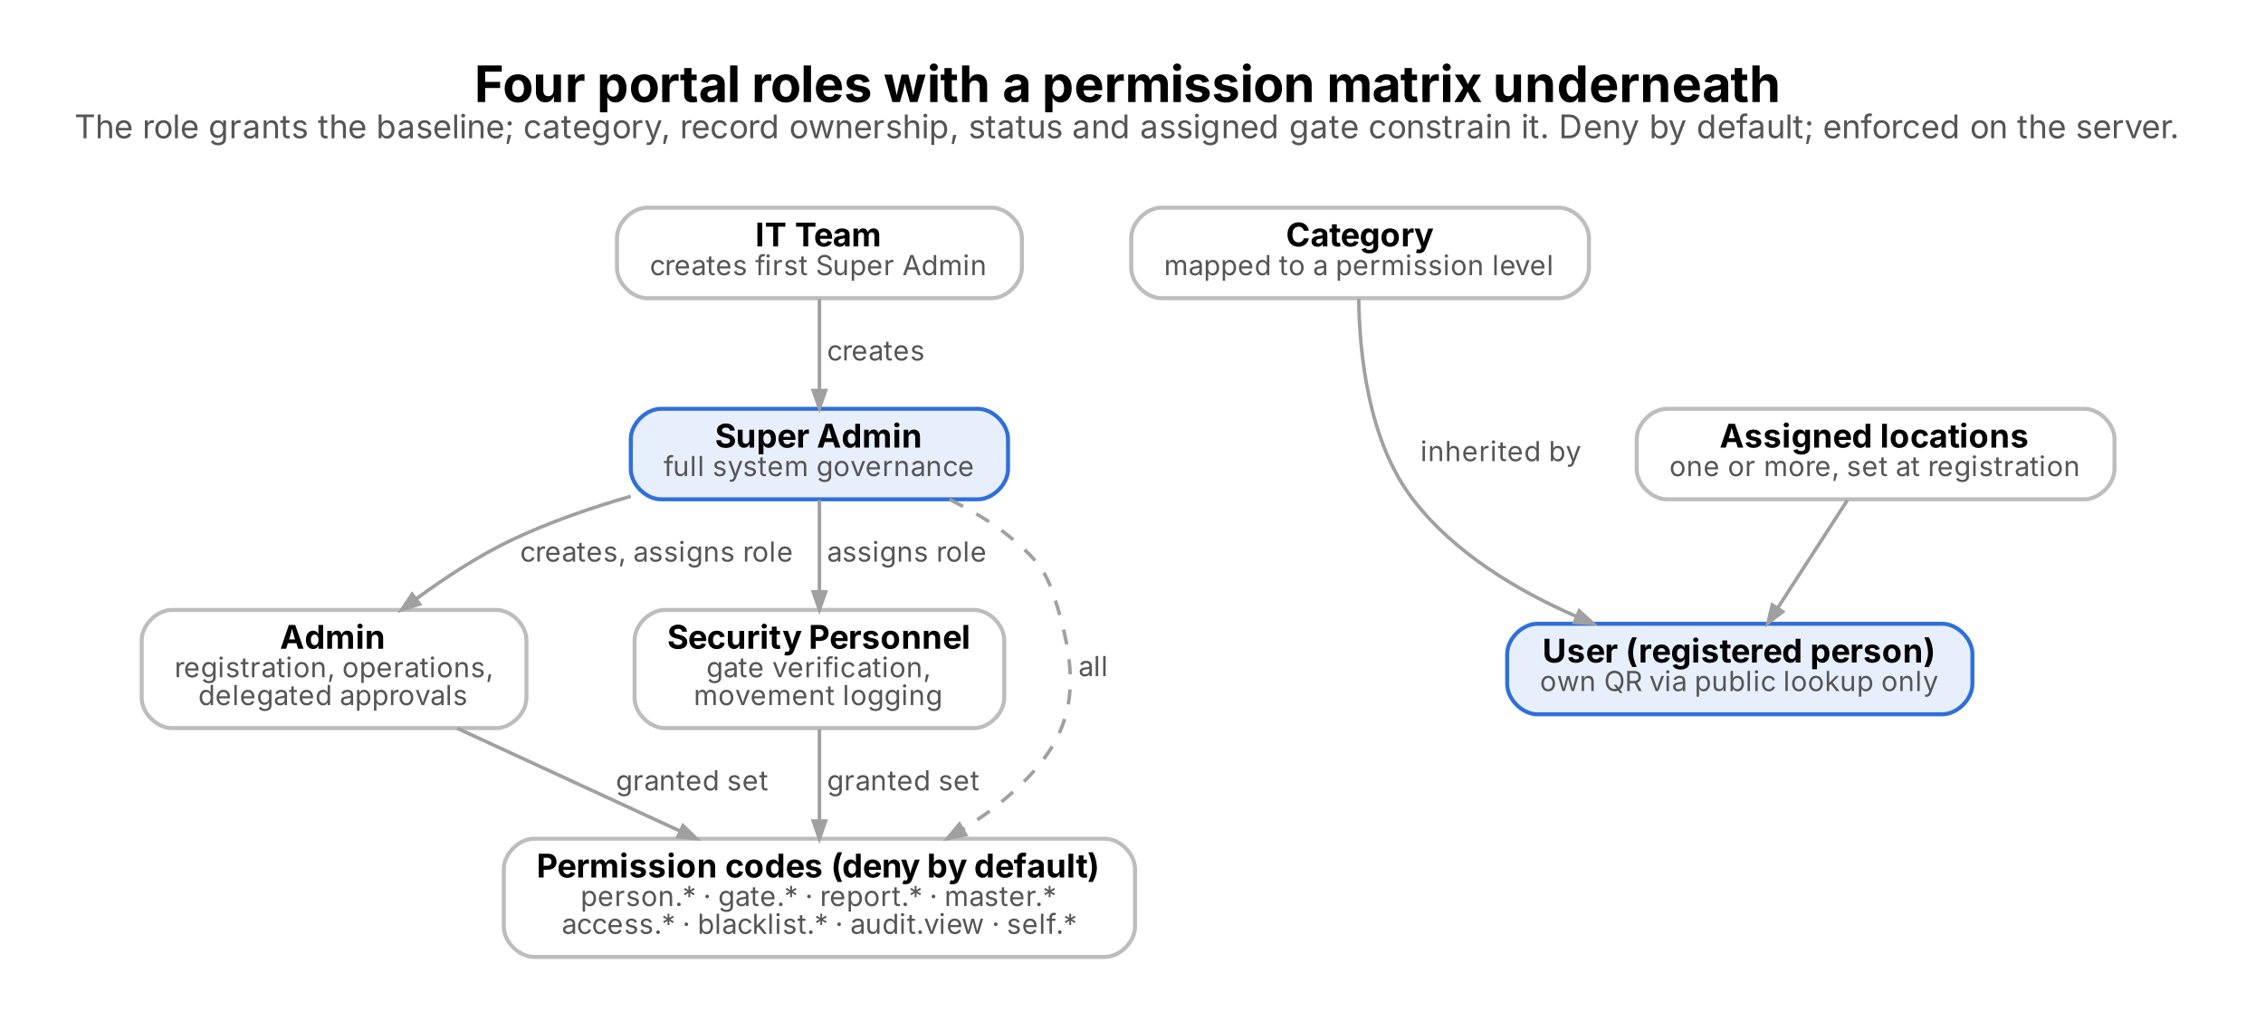
Figure 3. Portal roles, permission codes and category permission levels

4. Master Data Management
Admin (with configuration permission) and Super Admin maintain every list below from the Master Data screen without code changes. Authenticated users read active values; administrators also see inactive values and can reactivate them. A value already used by records is deactivated rather than deleted: deactivated values are hidden from new entries and kept on existing records. Unused values can be deleted. Every create, update and status change is audited.

4.1 Category Master
Field | Mandatory | Validation
Category name | Yes | Unique; ≤ 50 characters
Icon | No | Shown on the category picker
Description | No | ≤ 200 characters
Form type | Yes | Staff, Parivar, Visitor, Vendor, Contractor, Participant or Generic; selects the built-in form fields (sections 7 to 12)
Approval required | Yes | Yes, No or Not set. Seeded Yes for Staff and Parivar Member, No for others. Not set blocks registration until the rule is confirmed
Permission level | No | From Permission Level master; default for persons in the category
Broad category | No | Volunteer, Active Member or Visitor
Overstay cut-off time | No | Time of day after which a person still inside raises an overstay alert (for example 10:00 PM)
Registration form schema | No | Category-specific fields (see 4.1.1); when empty the built-in fields for the form type apply
Status | Yes | Active or Inactive

Examples / seed values: Staff, Visitor, Vendor, Contractor, Participant, Parivar Member. Broad categories: Volunteer, Active Member and Visitor. Devotee is not a separate category and is registered as Visitor.
# | Validation condition
1 | Category name mandatory
2 | Category name must be unique
3 | At least one category must stay active
4 | Changing the approval flag or cut-off applies to new registrations and future visits only
5 | A category whose approval rule is Not set cannot accept a registration submission
6 | Category name, permission level and broad category references must be valid; invalid references are rejected

Admin can: Create, update, activate, deactivate and edit the registration form schema. No approval workflow applies; changes take effect immediately and are audited. Delete is allowed only when the category is unused.
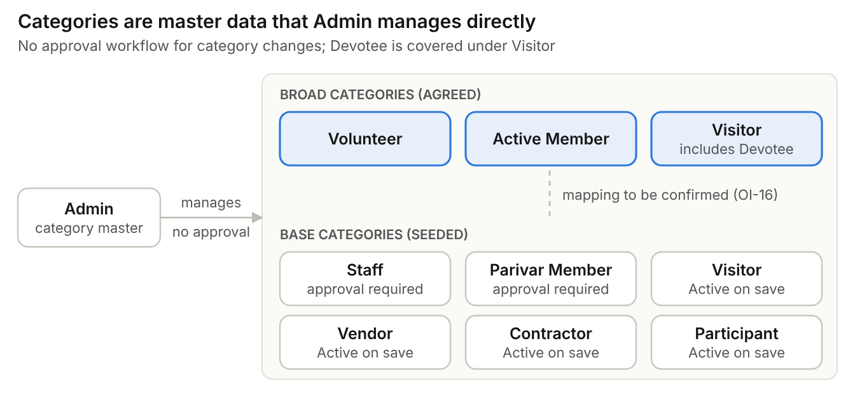
Figure 4. Category model: broad and seed categories
4.1.1 Registration form schema
Admin edits the category-specific part of the registration form from the Categories screen. Fields can be added, removed and reordered; registration then renders the saved schema and the server re-validates every value.
Property | Rule
Number of fields | Up to 50 per category
Field key | Unique within the schema; lower-case, pattern [a-z][a-z0-9_]{0,49}
Label and required flag | Label shown on the form; required fields must be non-empty
Field type | Text, date (valid ISO date), number (positive whole number) or select
Select source | Department, Job Role, Subcategory, Program / Batch, ID Proof Type, Blacklist Reason, Permission Level or Area master, or a custom list of options
Address and emergency contact | Switches that make address and emergency contact mandatory for the category
Named document rules | Mandatory named documents (for example ID proof, appointment letter) can be defined per category

4.2 Subcategory (Member Type) Master
Field | Mandatory | Validation
Category | Yes | Parent category, for example Parivar Member
Subcategory name | Yes | Unique within the category
Status | Yes | Active or Inactive

Examples / seed values: Sevak, Matri
# | Validation condition
1 | Subcategory mandatory
2 | Duplicate value not allowed within the same category

Admin can: Add, edit, activate, deactivate and delete (delete only when unused)

4.3 Department Master
Field | Mandatory | Validation
Department name | Yes | Unique
Status | Yes | Active or Inactive

Examples / seed values: Gurukul, Goushala, Accounts, Security, Housekeeping
# | Validation condition
1 | Department name mandatory
2 | Department name unique

Admin can: Add, edit, activate and deactivate

4.4 Job Role Master
Field | Mandatory | Validation
Department | Yes | From Department master
Job role name | Yes | Unique within the department
Status | Yes | Active or Inactive

Examples / seed values: Teacher, Driver, Guard, Supervisor, Housekeeper, Gardener
# | Validation condition
1 | Job role mandatory
2 | Duplicate role not allowed within the same department

Admin can: Add, edit, activate and deactivate

4.5 Location (Gate and Area) Master
Field | Mandatory | Validation
Location name | Yes | Unique
Type | Yes | Gate or Area
Area access | Conditional | Open or Restricted; mandatory when type is Area; a Gate cannot be restricted
Default for department | No | Department whose persons are tagged to this area automatically, for example Gurukul
Status | Yes | Active or Inactive

Examples / seed values: Gates: Main Gate and other access points. Restricted areas: Kitchen, Offices, Residential Areas, School / Gurukul. Open areas and other areas such as Goushala and Hostel are set by Admin.
# | Validation condition
1 | Location name mandatory
2 | Duplicate location not allowed
3 | Area access (Open or Restricted) mandatory for areas
4 | A Gate cannot be marked Restricted

Admin can: Add, edit, activate and deactivate; mark areas open or restricted. Admin can also assign gates to devices and shifts.
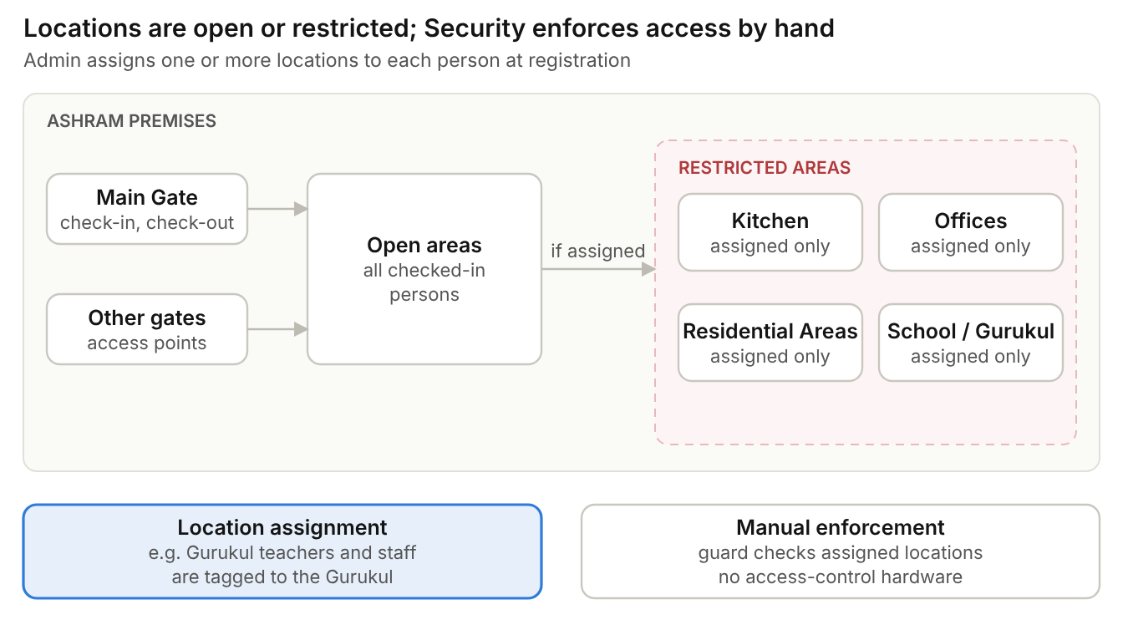
Figure 5. Gates, open areas and restricted areas

4.6 Program and Batch Master
Field | Mandatory | Validation
Program name | Yes | Unique
Batch | Yes | Unique within program
Start date, end date | Yes | End date on or after start date

Examples / seed values: Supplied by the Ashram (meditation programs, workshops, training sessions)
# | Validation condition
1 | End date cannot be before start date

Admin can: Add, edit, activate and deactivate. Program and Batch values must exist before Participant registration. A Participant’s access expiry is derived from the batch end date.

4.7 ID Proof Type Master
Field | Mandatory | Validation
ID proof name | Yes | Unique
Number pattern | No | Format check for the number; Aadhaar, PAN and Passport patterns configured
Storage | System | Number encrypted (AES-256-GCM) before storage; only the last 4 digits are displayed; the full value is never returned by ordinary profile reads and never kept in drafts

Examples / seed values: Aadhaar, PAN, Driving Licence, Voter ID, Passport
# | Validation condition
1 | Name unique
2 | Number checked against its pattern when entered

Admin can: Add, edit, activate and deactivate

4.8 Blacklist Reason Master
Field | Mandatory | Validation
Reason | Yes | Unique
Status | Yes | Active or Inactive

Examples / seed values: Supplied by the Ashram
# | Validation condition
1 | Reason unique

Admin can: Add, edit, activate and deactivate

4.9 Permission Level Master
Field | Mandatory | Validation
Permission level | Yes | Unique; predefined list
Description | No | What the level allows, including default location access
Status | Yes | Active or Inactive

Examples / seed values: Agreed with Ashram Management
# | Validation condition
1 | Permission level unique

Admin can: View, activate, deactivate and map levels to categories

5. User Management Module
Portal users sign in with username and password. No OTP, email link, SMS or WhatsApp message is used anywhere in login or password handling; OTP is excluded from Phase 1 because of its recurring operational cost. Accounts are provisioned with a one-time temporary password that the user must replace at first sign-in.
User type | Created by | How
Super Admin | IT team | First Super Admin inserted by the IT team at deployment; later Super Admins created by a Super Admin
Admin | Super Admin | User Management screen; temporary password issued
Security Personnel and operational Admin accounts | Super Admin (role assignment); Admin for operational accounts, subject to policy | User Management screen; temporary password issued

5.1 Create portal user
Field | Mandatory | Validation
First name | Yes | Not empty; ≤ 100 characters
Last name | Yes | Not empty; ≤ 100 characters
Mobile number | Yes | 10 digits; unique among portal users
Email | No | Valid format; unique if entered
Username | Yes | ≤ 50 characters; unique; matched case-insensitively at login
Role | Yes | Super Admin, Admin or Security Personnel; roles are assigned only by a Super Admin
Security Head | No | Flag; user receives blacklist and overstay alerts
Bulk upload permission | No | Flag; can be set or cleared later from the user list
Status | System | Active on creation; Admin can deactivate
Password | System | Never typed by the creator; a temporary password is issued after the account is saved

5.2 User creation flow
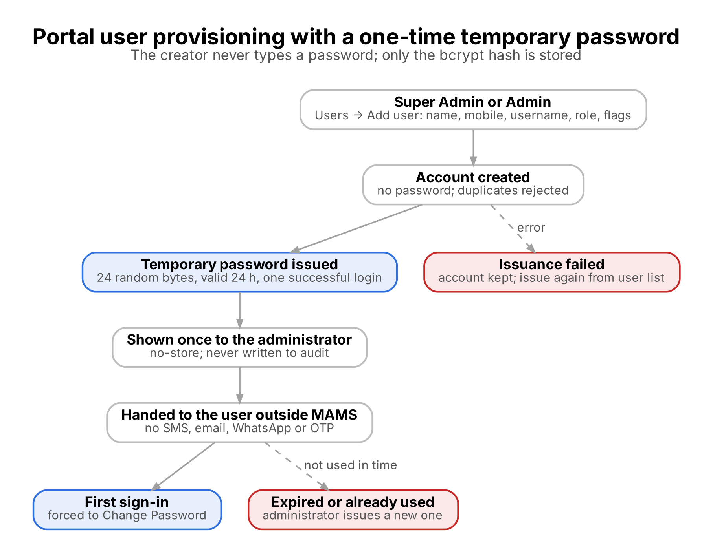
Figure 6. Portal user provisioning with a temporary password
Step | Administrator action | System response
1 | Users → Add user; enter details and role | Validates fields; duplicate username, email or mobile rejected
2 | Save | Account created without a password and audited
3 | (automatic) | Temporary password issued: 24 cryptographically random bytes, base64url; valid 24 hours; usable for one successful login. Only the bcrypt hash is stored
4 | Copy the credential panel (username, temporary password, expiry) | Shown once; response marked no-store; password never written to the audit log (MSG-SEC-03)
5 | Give the credential to the user outside MAMS | No SMS, email, WhatsApp or OTP delivery
6 | If step 3 fails | Account is kept and the failure is reported; issue the password again from the user list (MSG-SEC-11)

5.3 Login and password flow
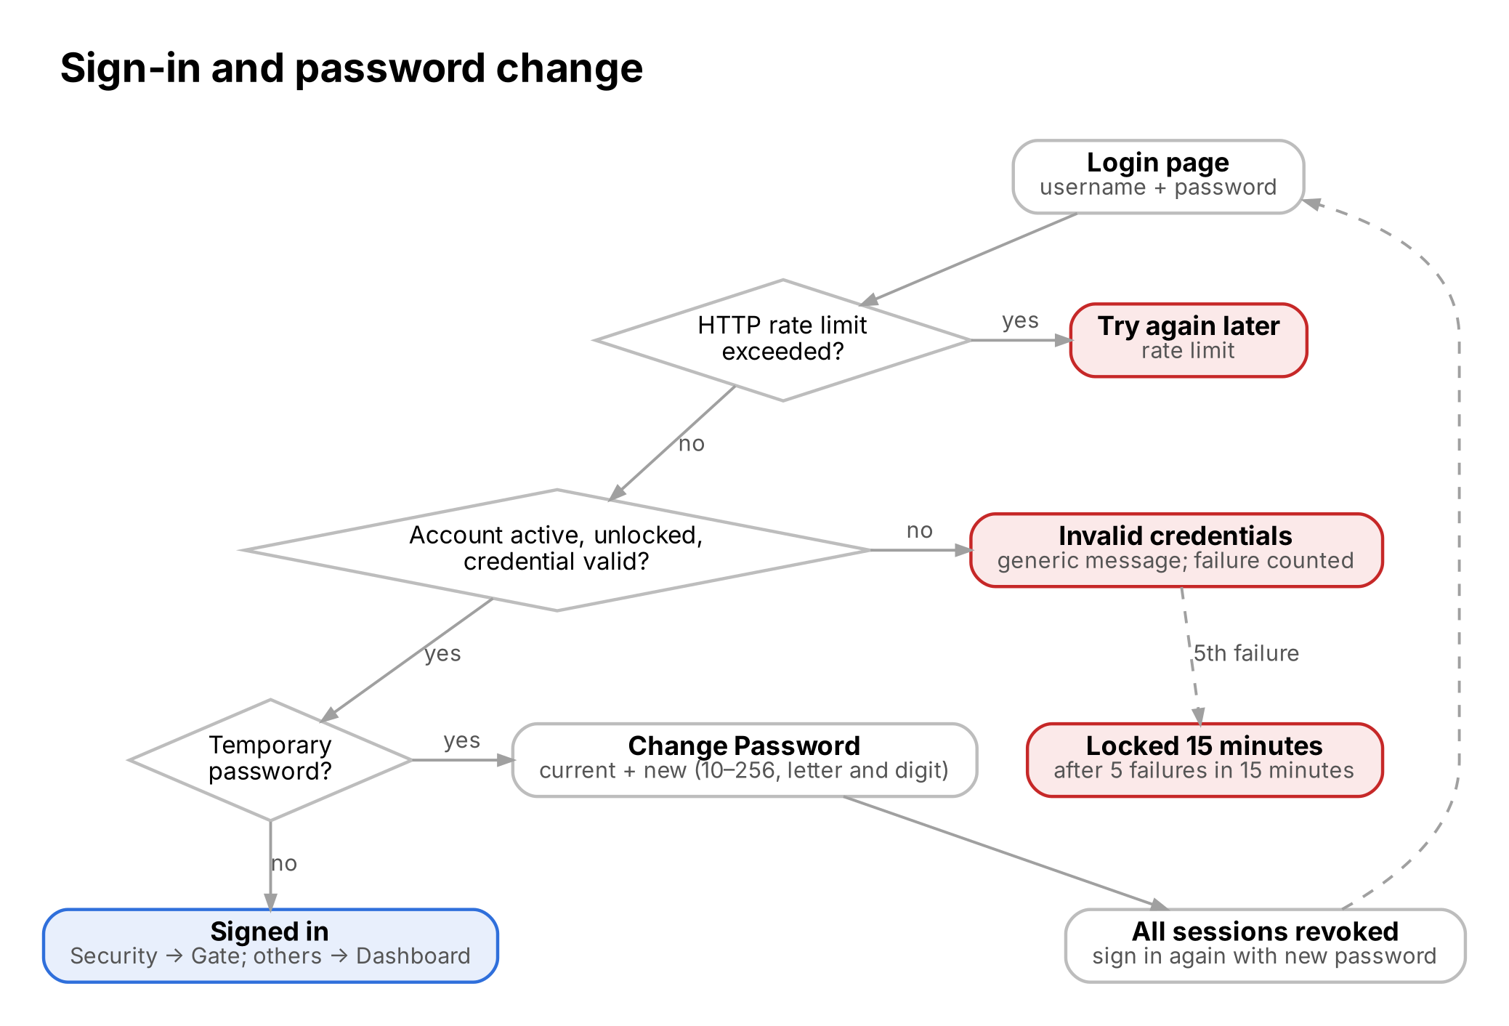
Figure 7. Sign-in and password change
Condition at login page | System behaviour | Message
Username not found, user Inactive, wrong password, temporary password expired or already used | Login refused with one generic message; wrong passwords counted | MSG-SEC-01
5 wrong passwords in 15 minutes | Account locked for 15 minutes | MSG-SEC-02
Too many login requests from one client | Refused by the HTTP rate limiter (window and limit set per deployment) | MSG-SEC-10
Valid temporary password | Signed in; temporary password consumed; user forced to Change Password before any other screen | MSG-SEC-05
Valid permanent password | Signed in to the role’s landing screen; failure count cleared | —

5.4 Change Password (first login and on demand)
Field | Mandatory | Validation
Current password | Yes | Must match the current (or temporary) password (MSG-SEC-06)
New password | Yes | 10 to 256 characters with at least one letter and one digit
Confirm password | Yes | Must match new password (MSG-SEC-07)

On save the new password is stored as a bcrypt hash, the forced-change and temporary-password state is cleared, every existing session is revoked and the user signs in again with the new password (MSG-SEC-09). The new password must differ from the current one (MSG-SEC-08).

5.5 Forgotten password
There is no self-service Forgot Password option. A user who cannot sign in asks an administrator, who issues a new temporary password (5.6).

5.6 Password reset by administrator
Situation | Action | Result
User forgot the password or the account is locked | Admin issues a new temporary password (Super Admin for an Admin account) | Lock and failure count cleared; all sessions revoked; user must change password at next login; reset audited (actor, target, expiry)
Temporary password expired or already used before the change was completed | Admin issues another temporary password | Previous temporary password no longer works
Target account is Inactive | Reset refused | Reactivate the account first
Super Admin cannot log in | Another Super Admin issues a reset, or the IT team resets it in the database | Super Admin must change password at next login

5.7 Login, password and session rules
ID | Requirement
FR-SEC-01 | The first Super Admin is added by the IT team. Super Admin creates Admins and assigns roles; Admin manages operational accounts subject to policy. Only a Super Admin can assign portal roles.
FR-SEC-02 | Every account receives an administrator-issued temporary password (24 hours, one successful login, bcrypt hash only, no-store response, never audited in plain text).
FR-SEC-03 | A user signed in with a temporary password is routed to Change Password and cannot open any other screen until it is changed.
FR-SEC-04 | Passwords: 10 to 256 characters with a letter and a digit; bcrypt hash only. After 5 failed attempts in 15 minutes the account locks for 15 minutes (MSG-SEC-02).
FR-SEC-05 | Login is also protected by an HTTP rate limiter whose window and limit are explicit deployment settings.
FR-SEC-06 | Security Personnel sessions last 12 hours (a full shift); other roles’ sessions last 30 minutes.
FR-SEC-07 | One minute before a session expires the user sees a warning with a “Stay signed in” option (MSG-SEC-04).
FR-SEC-08 | Logout, password change and administrator reset revoke all of the user’s sessions immediately; every request re-checks account status and session version.
FR-SEC-09 | The session is held in browser memory only; reloading the page requires signing in again.
FR-SEC-10 | Admin can list and filter users, deactivate an active user, reset a password and set the bulk upload permission; changes take effect on the user’s next request and are audited.
FR-SEC-11 | Login, logout, failed login, lockout, password change and password reset are audited.
FR-SEC-12 | A new password must differ from the current password.

6. Person Registration Module
Only authorised portal users register persons; there is no public self-registration. Registration is a five-step wizard: Category → Profile → Access → Documents → Review. The category, its form schema and the active master values come from the server; the server repeats every validation on submit. Fields in sections 7 to 12 are the built-in defaults for each form type; a category’s saved form schema (4.1.1) overrides them.

6.1 Registration flow
Step | User action | System response
1 Category | Select category | Shows active categories the role can register; Security Personnel see Visitor categories only (MSG-REG-07). A category whose approval rule is Not set cannot be submitted (MSG-REG-10)
2 Profile | Enter common fields (including Resident Status) and category fields | Validates each field; Job Role list filtered by the selected Department. Existing registrations on the mobile number listed for information (MSG-REG-01)
3 Access | Choose permission level, assigned areas, accompanying count and remarks | Permission level defaulted from the category; up to 100 active areas. Cleared by the server for Security walk-ins
4 Documents | Capture or upload the photo; attach optional documents | Photo mandatory, JPG or PNG ≤ 2 MB; up to 12 documents (PDF, JPG, PNG), ≤ 5 MB each
5 Review | Confirm consent and submit | Staff and Parivar Member (approval Yes): Pending, approvers notified. Other categories: Active, QR generated at once (MSG-REG-04)
Any step | Save as Draft | Stored without mandatory checks; visible and resumable only by its creator for 7 days; passport and ID numbers, consent and files must be entered again on resume

6.2 Common registration fields
Field | Mandatory | Validation
Person ID | System | MB- code, generated, read-only; one per registration
Category | Yes | Active category from Category master
Assigned permission level | No | Defaulted from the category’s permission level; cleared for Security walk-ins
Assigned location(s) | No | Up to 100 active areas from Location master; cleared for Security walk-ins; persons in a department linked to an area are tagged to it automatically
First name | Yes | Unicode letters, spaces and hyphens; 1 to 100 characters
Last name | Yes | Unicode letters, spaces and hyphens; 1 to 100 characters
Mobile number | Yes | 10 digits starting 6 to 9; duplicates allowed
Alternate mobile | No | 10 digits starting 6 to 9
Gender | Yes | Male, Female or Other
Date of birth | No | Valid date, not in the future
Resident status | Yes | Resident or Non-Resident / International; default Resident
Passport number | Conditional | Disabled when Resident; mandatory when Non-Resident / International; 6 to 9 letters and digits
Address | Category rule | Mandatory when the category schema requires it (default: Staff and Parivar Member)
Email ID | No | Valid format; ≤ 150 characters
Emergency contact name and mobile | Category rule | Mobile 10 digits starting 6 to 9; mandatory when the category schema requires it (default: Staff, Parivar Member, Participant)
Photograph | Yes | Camera capture or JPG / PNG upload, ≤ 2 MB; must decode as an image; rotated upright, resized within 600 × 600 px and stored as JPEG
Documents | No | Up to 12 files: PDF, JPG or PNG, ≤ 5 MB each, checked by content; stored privately
ID proof type and number | No | Type from ID Proof master is required when a number is entered; number checked against the type’s pattern; encrypted at rest; only last 4 digits shown
Accompanying members | No | Names, or a count, of people without their own mobile number (labour team, family, children, elderly); no Person ID or QR
Remarks | No | ≤ 500 characters
Consent | Yes | Must be confirmed; notice version, time and actor recorded
Source | System | Walk-in when registered by Security Personnel
Registered by, registration date, status | System | Set automatically

6.3 Validation rules
Field | Condition | Result if not met | Message
First / last name | Unicode letters, spaces and hyphens only; 1 to 100 characters | Field error; cannot save | MSG-REG-03
Mobile number | Mandatory; 10 digits starting 6 to 9 | Field error; cannot save | Field error
Mobile number | Already used on other registrations | Information only; save allowed | MSG-REG-01
Photo | Mandatory; JPG or PNG; ≤ 2 MB; must be a readable image | Field error; cannot save | MSG-REG-02
Email | Optional; valid format and ≤ 150 characters if entered | Field error; cannot save | Field error
Passport number | Mandatory when Resident Status is Non-Resident / International | Field error; cannot save | MSG-REG-08
Passport number | Non-Resident: 6 to 9 letters and digits | Field error; cannot save | MSG-REG-08
Passport number | Resident Status is Resident | Field disabled | —
Address | Mandatory when the category schema requires it | Field error; cannot save | Field error
ID proof number | Entered without an ID proof type, or not matching the type’s pattern | Field error; cannot save | Field error
Category fields | Required fields filled; dates valid; numbers positive whole numbers; select values allowed; Job Role belongs to Department | Field error; cannot save | Field error
Dates | Date of birth, joining date and member-since not in the future; contract end not before start | Field error; cannot save | Field error
Documents | PDF, JPG or PNG; ≤ 5 MB each; ≤ 12 files | Upload rejected | MSG-REG-12
Consent | Must be confirmed before submit | Cannot submit | MSG-REG-09
Category settings | Category approval rule or status changed while the form was open | Submission rejected; reload and review | MSG-REG-11

6.4 Registration rules
ID | Requirement
FR-REG-01 | The category’s approval rule decides the outcome: Yes → Pending (seeded for Staff and Parivar Member); No → Active with a QR (Visitor, Vendor, Contractor, Participant); Not set → submission blocked.
FR-REG-02 | Duplicate prevention is not enforced. A person may be registered more than once under different categories; each registration has its own Person ID, status and QR.
FR-REG-03 | Only people with a mobile number are registered as persons. Accompanying members (labour team, family, children, elderly) are recorded under the primary registrant and get no Person ID or QR.
FR-REG-04 | Only Admin and Super Admin can edit a Staff profile; no re-approval is needed. Contact and basic profile fields can be edited for other categories.
FR-REG-05 | Changing the mobile number of an Active person increases the QR version and invalidates the previous QR; other edits never change the QR.
FR-REG-06 | Admin or Super Admin can deactivate an Active person with a mandatory reason (≤ 300 characters) and reactivate with a reason; a deactivated person cannot check in.
FR-REG-07 | Persons are never hard deleted. Super Admin may soft-delete a record with a mandatory reason; history is kept and recoverable.
FR-REG-08 | Security Personnel can register only a Visitor; the server clears permission level and areas and marks the source as Walk-in.
FR-REG-09 | Admin assigns one or more areas and an access expiry date; changes are audited.
FR-REG-10 | The person inherits the permission level mapped to the category as the default; it is stored on the registration and shown at the gate.
FR-REG-11 | Changes to mobile number, email, passport, category and location are audited with old and new values.
FR-REG-12 | The person, area assignments, approval history, audit and notifications are saved in one transaction; files written for a failed submission are deleted.
FR-REG-13 | Drafts are private to their creator, kept for 7 days and never store passport or ID numbers or file content.
FR-REG-14 | Photos and documents are stored privately and served only through authenticated, record-checked routes; Security Personnel can view the photo but not documents.
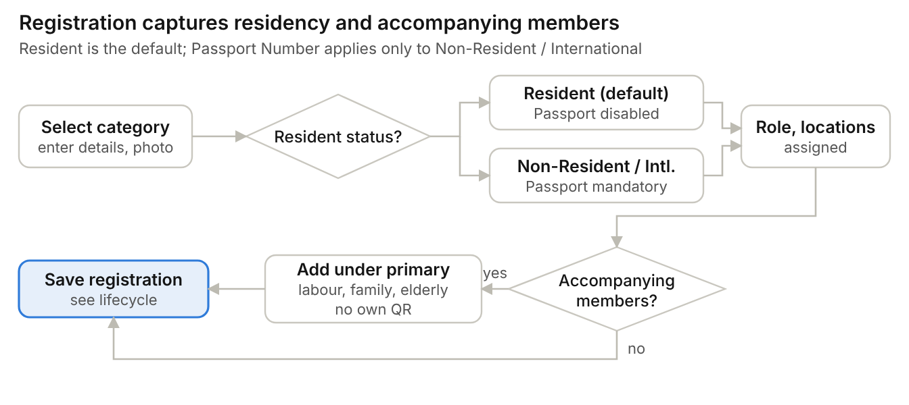
Figure 8. Registration data: residency and accompanying members

6.5 Bulk upload
Bulk upload registers many persons from one file. It is part of Phase 1 and is available only to users granted the bulk upload permission.
Step | User action | System response
1 | Open Bulk Upload | Shown only to users with the bulk upload permission
2 | Download the template | Template file (columns to be finalised)
3 | Upload the completed file | Upload initiated and audited
4 | Wait for validation | Each row checked with the rules in 6.2 and 6.3; valid rows saved, invalid rows listed with the reason
5 | Review the result | Summary of created and failed rows; unique QR generated for each created Active record; upload completed and upload errors audited

ID | Requirement
FR-BLK-01 | Bulk upload is available only to users granted the bulk upload permission; the permission is granted by Admin.
FR-BLK-02 | Each row is validated with the same field rules as manual registration. Failing rows are not saved and are reported with the row number and reason.
FR-BLK-03 | A unique QR is generated for each record created by a successful upload.
FR-BLK-04 | Upload initiated, upload completed and upload errors are written to the audit log.
FR-BLK-05 | The template defines the columns and how photographs are supplied; Staff and Parivar Member rows follow the approval workflow.
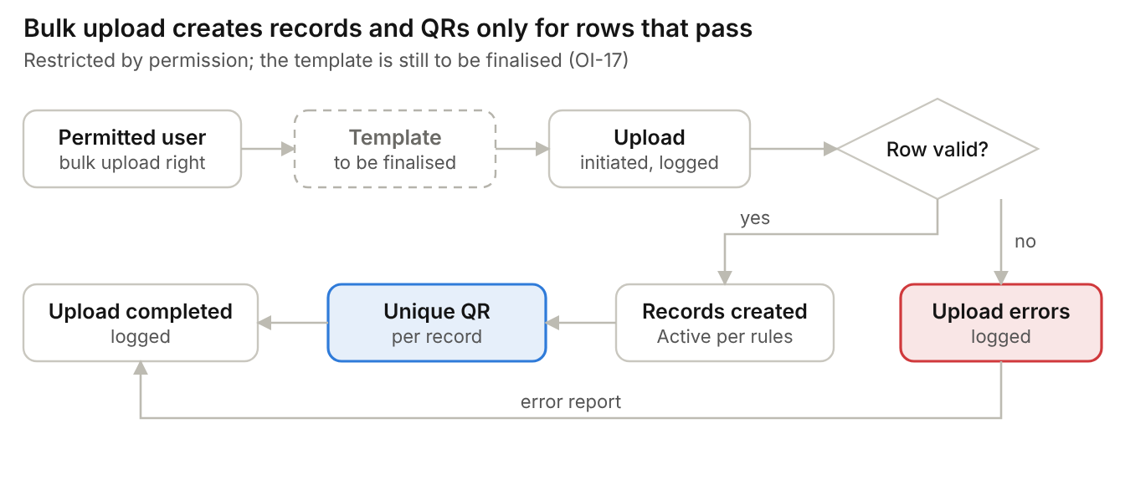
Figure 9. Bulk upload flow

7. Staff Registration
Field | Mandatory | Validation / notes
Department | Yes | From Department master
Job role | Yes | Shows only roles belonging to the selected department
Joining date | Yes | Not in the future
Residential address | Yes | ≤ 500 characters
Emergency contact name and mobile | Yes | Mobile 10 digits
Employee ID | No | Unique if entered
Employment type | No | Permanent, contract or seasonal
Shift | No | Free text
Documents | No | Optional attachments (ID proof, appointment letter); PDF, JPG or PNG, ≤ 5 MB each; mandatory documents as defined for the category

7.1 Staff registration flow
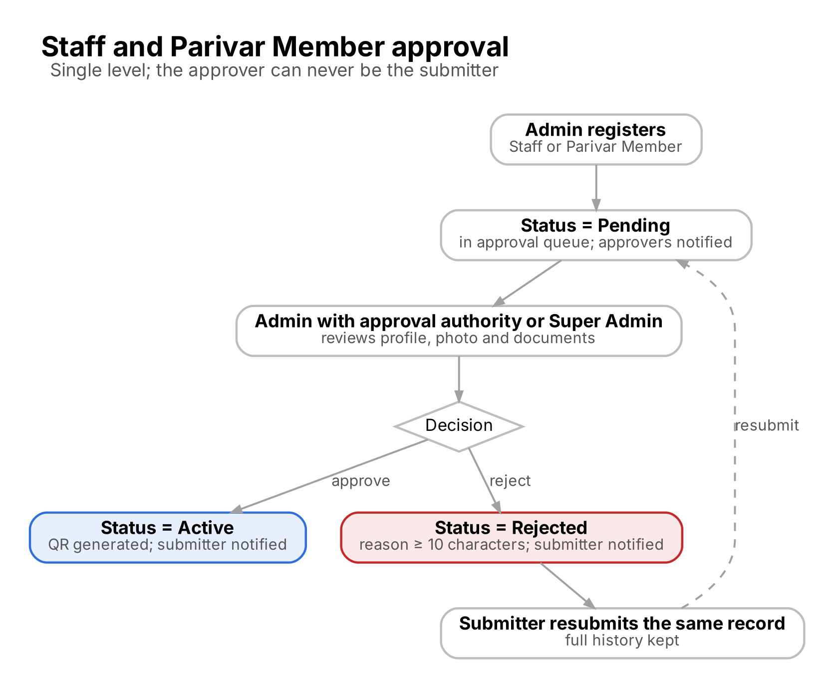
Figure 10. Staff and Parivar Member approval flow
If approved: status becomes Active and the QR is generated. If rejected: status becomes Rejected, the reason is mandatory, and the submitter edits and resubmits the same record.
Status: Pending until approved. Approval required: Yes.

8. Parivar Member Registration
Field | Mandatory | Validation / notes
Subcategory (Member Type) | Yes | From Subcategory master, for example Sevak, Matri
Residential address | Yes | ≤ 500 characters
Emergency contact name and mobile | Yes | Mobile 10 digits
Member since | No | Past date
Seva area | No | Free text
Referred by | No | Free text
Documents | No | ID proof, membership form

Flow: same as Staff (Figure 10): Admin registers → Pending → an Admin with approval authority or Super Admin, never the submitter, reviews → Approve or Reject. Approval required: Yes.

9. Visitor Registration
Field | Mandatory | Validation / notes
Purpose of visit | Yes | Free text or list
Visit date | Yes | Today or a future date
City | No | Free text
Person or department to meet | No | Free text
Expected duration | No | Hours
Vehicle number | No | Free text
Accompanying members | No | Family, children, elderly without a mobile phone; names or count

Registered by: Super Admin, Admin, or Security Personnel (walk-in fallback). Status: Active immediately (Pending only if the Visitor category is configured to require approval). Approval required: No. Devotees are registered as Visitors.

10. Vendor Registration
Field | Mandatory | Validation / notes
Firm name | Yes | ≤ 150 characters
Goods or services supplied | Yes | Free text
Receiving department | Yes | From Department master
GSTIN | No | 15-character GST format
Delivery frequency | No | Daily, weekly, occasional
Vehicle number | No | Free text
Business address | No | ≤ 500 characters

Status: Active immediately. Approval required: No.

11. Contractor Registration
Field | Mandatory | Validation / notes
Agency name | Yes | ≤ 150 characters
Nature of work | Yes | Electrical, construction, maintenance and so on
Supervising department | Yes | From Department master
Contract start and end date | Yes | End on or after start
Work order number | No | Free text
Work location | No | From Location master
Accompanying members (labour team) | No | Added under the contractor as primary registrant; individual registration of each labourer is not mandatory

Status: Active immediately. Approval required: No. The contractor is the primary registrant; labour team members are added as accompanying members on the contractor’s registration and at each check-in.

12. Participant Registration
Field | Mandatory | Validation / notes
Program and batch | Yes | From Program and Batch master
Program start and end date | Yes | Filled from the batch; sets the access expiry
Emergency contact name and mobile | Yes | Mobile 10 digits
City | No | Free text
Accommodation | No | Free text
Dietary or medical notes | No | Visible only to Super Admin and Admin users

Status: Active immediately. Approval required: No. Non-Resident / International participants must enter a Passport Number.

13. Registration Search Module
Search field | Rule | Result
Person ID | Exact match | One registration
Mobile number | 10 digits | All registrations on that number
Name | At least 3 characters; partial match | All matching registrations

Condition | System behaviour | Message
No search field entered | Search not run | MSG-REG-05
No record matches | Empty result shown | MSG-REG-06

13.1 Person list
Element | Behaviour
Columns | Photo, Person ID, name, category, subcategory or department, mobile (masked for non-Admin), status, blacklist flag, registered date
Filters | Category, status, department, assigned location, registered date range
Paging | 25 rows per page; sort by any column
Row actions | View, Edit (by permission), Print QR, Deactivate (Admin, Super Admin), Blacklist (Admin with blacklist.manage, Super Admin)

14. Approval Module
Super Admins and Admins with approval authority (person.approve) work one queue with Pending, Active and Rejected tabs. Approval is single-level.

14.1 Pending list screen
Column | Description
Registration number (Person ID) | MB-nnnnnn
Photo and person name | Thumbnail and full name
Category | Staff or Parivar Member
Department or subcategory | Department for Staff; subcategory for Parivar Member
Mobile | Masked for non-Admin
Submitted by | Portal user
Submitted date | Date and time
Age of request | Days waiting; default sort oldest first

Filters: category, submitted date range, submitted by. Opening a row shows the full profile, photo and documents before a decision.

14.2 Approve, reject and resubmit
ID | Requirement
FR-APR-01 | Allowed roles: Super Admin and Admin with approval authority.
FR-APR-02 | Approve: Pending → Active; QR generated; submitter notified.
FR-APR-03 | Reject: reason mandatory, at least 10 non-blank characters (MSG-APR-01); Pending → Rejected; rejector and date recorded; submitter notified.
FR-APR-04 | Resubmit: the submitter or Admin views the reason, edits the same rejected record and resubmits; Rejected → Pending. No new registration is created and the full history is kept.
FR-APR-05 | Bulk: select up to 50 rows; approve all, or reject all with one shared reason; each record audited individually.
FR-APR-06 | No user can approve or reject a registration they submitted, whatever their role (MSG-APR-02).
FR-APR-07 | A decision on a record that is no longer Pending, or already decided by someone else, is refused (MSG-APR-03).
FR-APR-08 | Status, approval history, audit and notifications are updated in one transaction.

Figure 11. Approval, rejection and resubmission

15. QR Management Module

15.1 QR generation
Category | QR generated
Staff | After approval
Parivar Member | After approval
Visitor | Immediately after registration
Vendor | Immediately after registration
Contractor | Immediately after registration
Participant | Immediately after registration
Any category by bulk upload | After a successful upload; Staff and Parivar Member rows after approval

15.2 QR content and rules
ID | Requirement
FR-QR-01 | Every registered individual gets a unique QR. The QR carries a signed token built on the Person ID, so it stays unique when several registrations share one mobile number: AMS1.<Person ID>.<QR version>.<signature>, signed with HMAC-SHA256 (base64url).
FR-QR-02 | One QR per registration; accompanying members do not get a QR. The QR never expires (access expiry is checked separately at the gate).
FR-QR-03 | The QR is regenerated only when the registered mobile number changes. The version increases by 1 and the previous QR is rejected immediately (MSG-GATE-01). Signatures are compared in constant time.
FR-QR-04 | Authorised users preview, download and print the QR; the printed card shows name, Person ID and category.
FR-QR-05 | Distribution is manual: the person downloads the QR from the public lookup page, or authorised staff print it at the front desk and hand it over.
FR-QR-06 | Automatic sharing of the QR by SMS, Email or WhatsApp is not included in Phase 1 because of recurring operational cost.
FR-QR-07 | Every QR generation and regeneration is audited.
FR-QR-08 | Admin manually reissues a QR, and the QR screen shows KPIs and category filters.
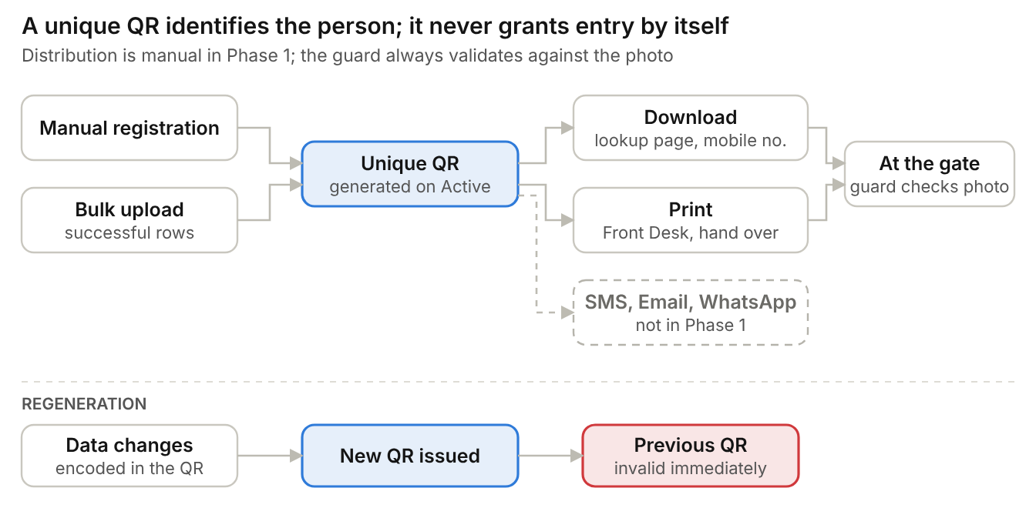
Figure 12. QR generation, distribution and regeneration

16. Public QR Download Module
No login required. No OTP (excluded from Phase 1 due to recurring operational cost) or CAPTCHA. The page is rate limited per client (limit set per deployment), returns only name, category and QR image, and masks the mobile number in its logs. The QR is a lookup mechanism, not proof of authorization (FR-RBAC-10); Security Personnel validate the person at the gate against the profile photo.

16.1 Search field
Field | Mandatory | Validation
Mobile number | Yes | 10 digits starting 6 to 9

16.2 Flow
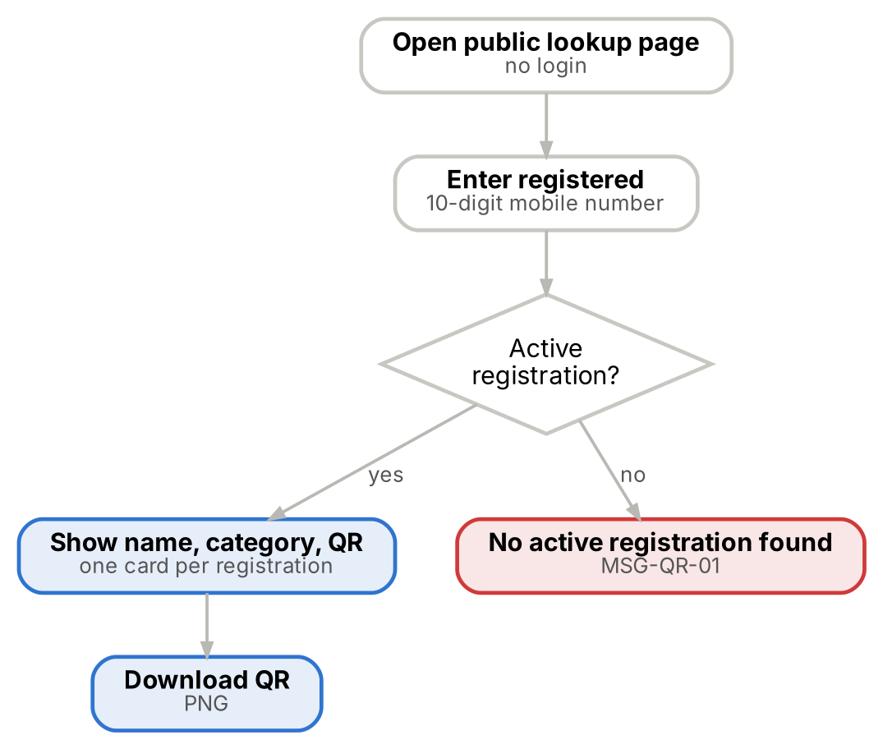
Figure 13. Public QR download
Step | Person action | System response
1 | Opens the public lookup page | Shows mobile number field; no login, OTP or CAPTCHA
2 | Enters registered mobile number and taps Search | Finds Active, non-blacklisted registrations on that number
3 | Views results | One card per registration with name, category and QR
4 | Taps Download | QR downloaded as PNG; shown at the gate

16.3 Validation
Condition | System behaviour | Message
Mobile number not 10 digits | Search not run | Field error
Too many lookups from one client | Request refused for a short period | MSG-QR-02
No registration on the number | No QR shown | MSG-QR-01
Registration Pending, Rejected, Deactivated or Blacklisted | No QR shown; status not disclosed | MSG-QR-01
One or more Active registrations | QR card shown for each | —
Every lookup | Written to audit log with masked mobile and result | —

17. Gate Verification Module
The gate screen gives one decision per person: a green Check In / Check Out button, or a red block with the reason. It is designed for a phone or tablet held in one hand and is used by Security Personnel (and by Admin and Super Admin). MAMS manages multiple gates and access points; no access-control hardware is used, so Security Personnel validate identity and location access manually.

17.1 Gate screen
ID | Requirement
FR-GATE-01 | The guard selects the gate and an active area before looking anyone up; lookup against an inactive or unknown location is refused. The device remembers the selection until changed; gates can be assigned to devices and shifts.
FR-GATE-02 | Scan mode opens the rear camera in the browser and reads continuously; a torch toggle is available.
FR-GATE-03 | Lookup accepts exactly one of: QR payload, 10-digit mobile number, or name / Person ID text. More than one match shows a picker with photos, categories and masked mobile numbers.
FR-GATE-04 | The guard confirms the person against the profile photo before tapping Check In and is accountable for this check. A legacy record without a photo can have one captured at the gate.
FR-GATE-05 | The gate screen shows the person’s assigned locations and permission level. When the selected area is restricted and not assigned to the person, the screen shows a warning (MSG-GATE-08); the guard either refuses entry or explicitly acknowledges an override, which is stored on the visit and in the audit log. Open areas need no assignment.
FR-GATE-06 | Every lookup is recorded with actor, location, number of matches, outcome and masked mobile number.

17.2 Security screen information
Field | Shown as
Photo | Large photo for visual comparison
Name | Full name
Person ID | MB-nnnnnn
Category | With subcategory or department
Assigned locations | List of assigned locations; restricted areas flagged
Mobile number | Masked, last 4 digits
Status | Active, Pending, Rejected or Deactivated
Blacklist status | Red banner when blacklisted
Inside / Outside | With time, gate and location of the open visit
Accompanying members | Names or count recorded on the registration

17.3 Eligibility check (server-side, in this order)
# | Check | If it fails | Message
1 | QR signature and version valid | Block | MSG-GATE-01
2 | Person exists | Offer walk-in Visitor registration | MSG-GATE-02
3 | Not blacklisted today | Block; red alert; notify Admins and Security Head | MSG-GATE-03
4 | Status is Active | Block | MSG-GATE-04
4a | Access expiry date not passed | Block | MSG-GATE-05
5 | No open visit | Block check-in; offer Check Out | MSG-GATE-06
6 | Assigned to the selected location (restricted areas only) | Warning; guard refuses entry or acknowledges a recorded override | MSG-GATE-08

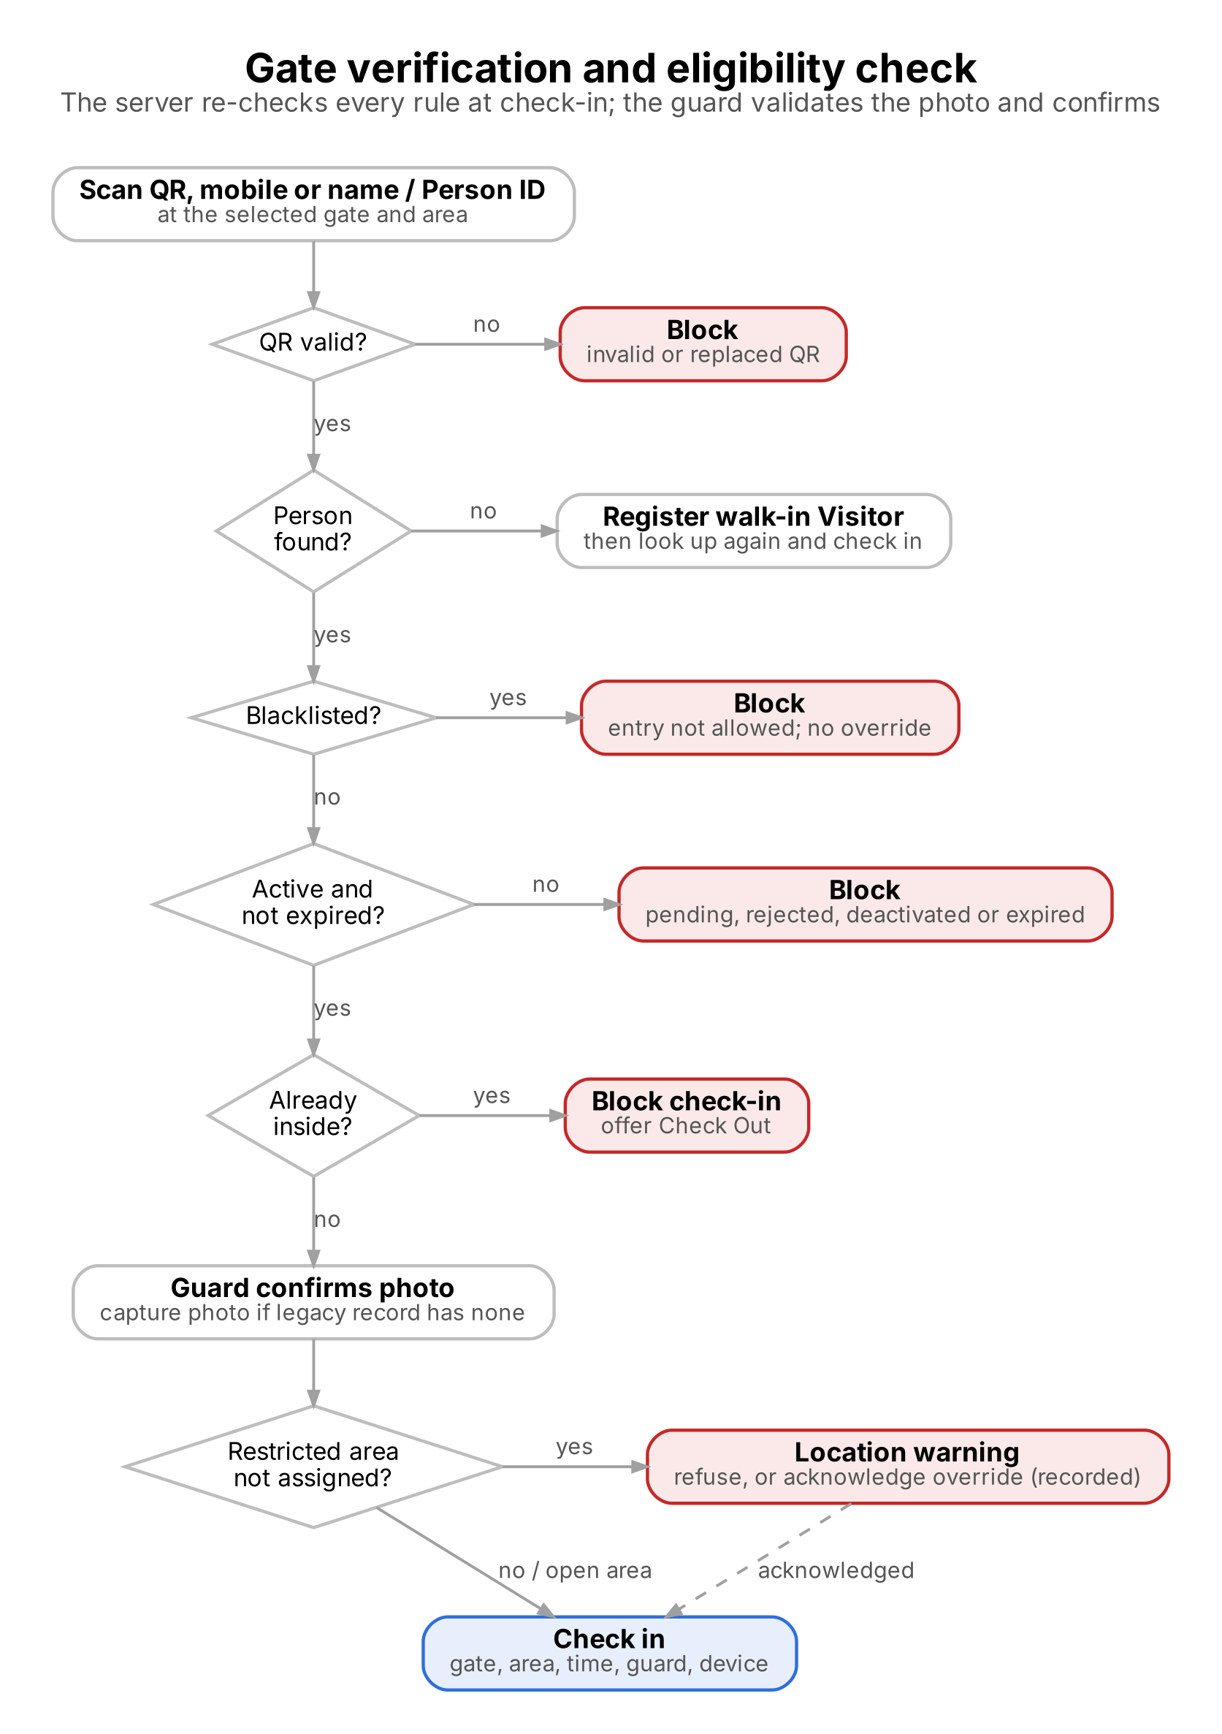
Figure 14. Gate verification and eligibility check
Every blocked attempt is stored with its result and reason and counts in "Blocked attempts today".

17.4 Person not found: walk-in Visitor
Step | Guard action | System response
1 | Search returns no match | Shows Registration required (MSG-GATE-02) and Register Visitor button
2 | Opens the Visitor registration | Visitor categories only: name, mobile, gender, resident status, photo, consent, purpose, person to meet, accompanying count
3 | Taps Save | Visitor registered as Active (or Pending if the Visitor category requires approval); permission level and areas cleared; source Walk-in; returns to the Gate with the Person ID and the selected gate and area
4 | Confirms the photo and taps Check In | Normal eligibility check runs and the check-in is recorded

Condition | Rule
Entry without registration | Not allowed: visitor registration is mandatory before entry
Automatic check-in on registration | Not provided: check-in is always a separate, confirmed action
Pending walk-in | Cannot be checked in until approved

17.5 Blacklist check
When a blacklisted person is found the screen shows BLACKLISTED PERSON — ENTRY NOT ALLOWED (MSG-GATE-03) and check-in is blocked; no role can override the block. Admins and the Security Head are alerted.

17.6 System or network unavailable
If the system or network is down at a gate, the guard records entry and exit in the manual register and entry continues on paper. The application does not queue or replay offline gate events. Register entries remain on paper and are not back-entered into the system.

18. Check-In Module
Allowed roles: Security Personnel, Admin, Super Admin. The server re-checks every rule at the moment of check-in; a successful lookup does not reserve entry.

18.1 Validation rules
Rule | If it fails | Message
Person must exist | Registration required | MSG-GATE-02
Person must be Active | Approval required / Registration rejected / Profile deactivated | MSG-GATE-04
Access expiry date not passed | Access expired | MSG-GATE-05
Person must not be blacklisted | Entry blocked | MSG-GATE-03
Duplicate entry prevention: only one open visit per person | Person already inside | MSG-GATE-06
Restricted area not assigned | Warning; check-in only after acknowledged override | MSG-GATE-08

Example: check-in done, no check-out recorded, second check-in attempted = blocked with "Person already inside since [time] at [point]".

18.2 Check-in data captured
Field | Source
Person | Scanned or searched registration
Check-in gate | Selected on the device
Check-in area | Selected on the device
Date and time | Server clock, IST
Checked in by | Logged-in user
Device | Device and request details where supplied
Accompanying members | Names or count, pre-filled from the registration and editable
Location override | Set when the guard acknowledged a restricted-area warning

Double-tap protection: the same action for the same person within 5 seconds is ignored. Exactly one open visit per person is enforced by the server and database.

19. Check-Out Module

19.1 Validation
Condition | System behaviour | Message
Person has an open check-in | Check-out allowed at any gate | —
Person has no open check-in | Check-out blocked | MSG-GATE-07
Person has an open visit and is blacklisted | Check-out allowed (blacklist blocks entry only) | —

19.2 Check-out data captured
Field | Source
Person | Scanned or searched registration
Check-out gate | Selected on the device
Check-out area | Selected on the device
Check-out time | Server clock, IST
Checked out by | Logged-in user
Device | Device name
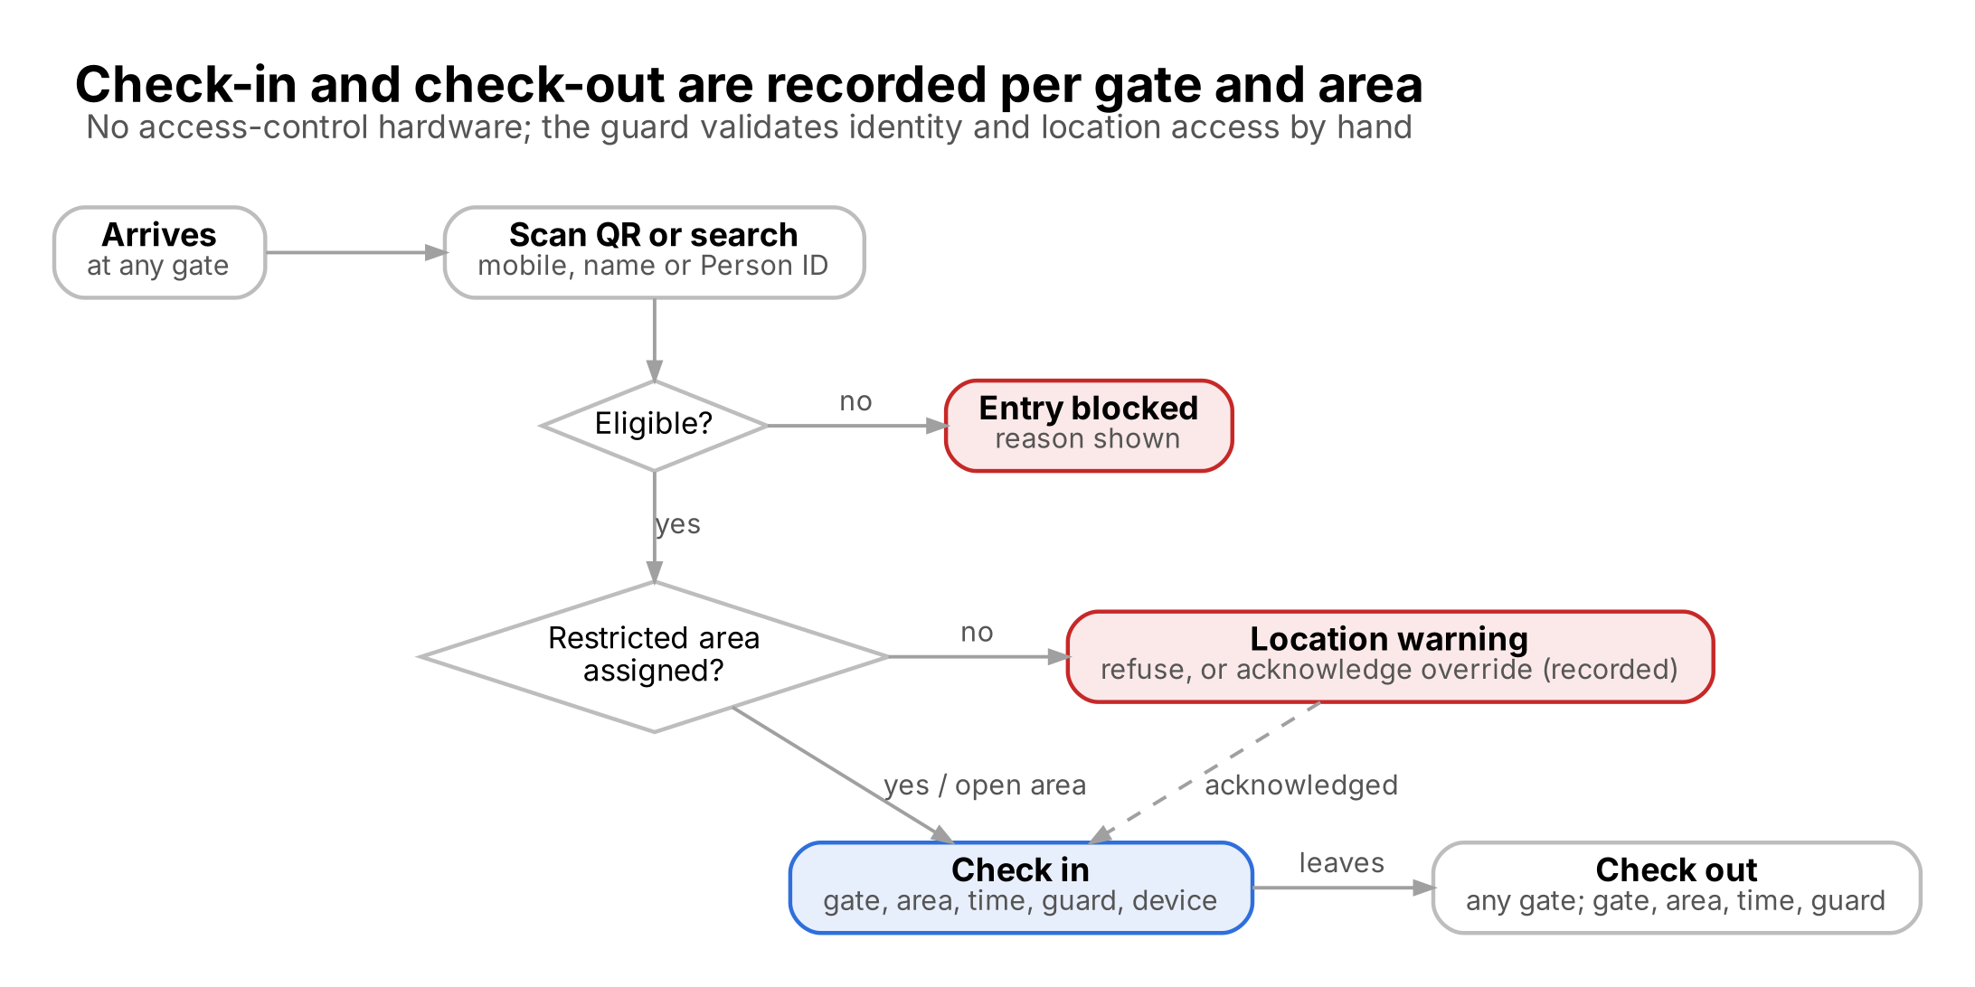
Figure 15. Check-in and check-out with gate and location

20. Occupancy Module

20.1 Logic
Current occupancy = number of open visits (check-ins without a check-out). This equals total check-ins minus completed check-outs, and makes a forgotten check-out visible instead of hiding it. Occupancy is shown for the whole Ashram and by location. Accompanying members recorded at check-in are added to the occupancy count and also shown separately (for example "485 inside, including 32 accompanying").

20.2 Dashboard widgets
Widget | Definition | Refresh
Current occupancy | Open visits now, by category and by location | 30 s
Today's check-ins | Check-ins since 00:00 IST | 30 s
Today's check-outs | Check-outs since 00:00 IST | 30 s
Pending approvals | Persons in Pending status; links to the approval queue | 60 s
Blacklisted attempts | Check-in attempts blocked by the blacklist today | 30 s
Inside list | Persons checked in but not checked out; overstays highlighted | 60 s
Recent activity | Last 10 gate events | 30 s

20.3 Inside list and overstay
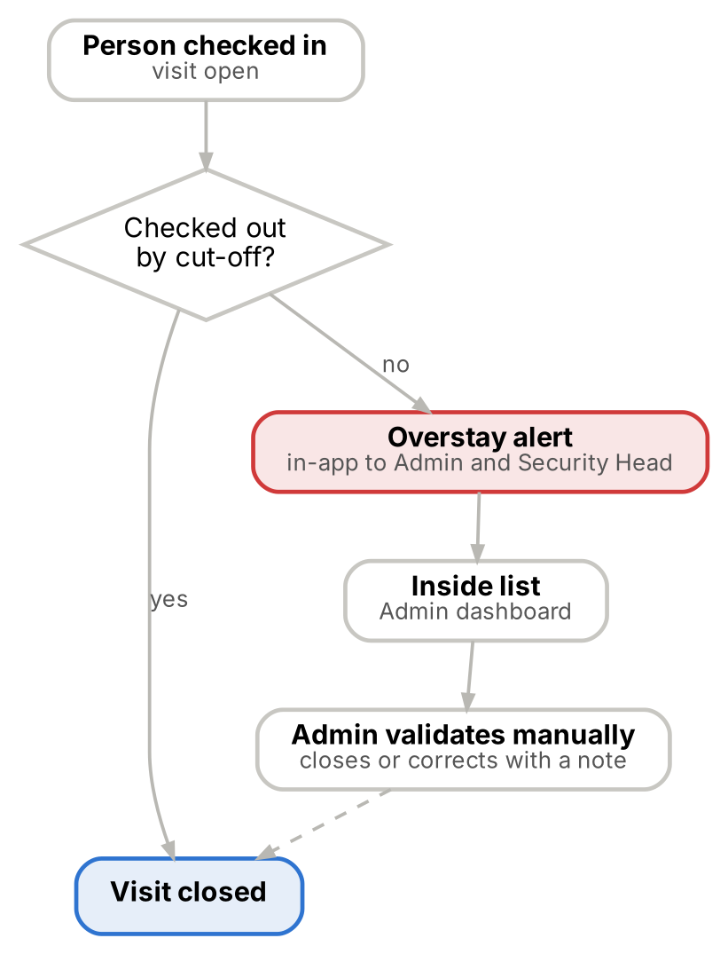
Figure 16. Inside list, overstay alert and Admin validation
ID | Requirement
FR-OCC-01 | There is no auto-checkout.
FR-OCC-02 | Overstay: a person still inside after their category’s cut-off time raises an in-app overstay alert. Day visitors and contractors must leave by 10:00 PM; cut-offs for other categories are set in the Category master.
FR-OCC-03 | The Inside list on the Admin dashboard and in reports shows every open visit with person, category, check-in time, gate and hours inside; overstays are highlighted.
FR-OCC-04 | Admin or Super Admin explicitly confirms and closes an open visit with a mandatory note (1 to 500 characters); the visit is marked closed by Admin and audited in the same transaction. A visit that is no longer open returns a conflict.

21. Blacklist Module

21.1 Add to blacklist
Super Admin, and Admin when blacklist management is delegated, can perform this. Security Personnel see the blacklist flag only. Any registered person of any category can be blacklisted.
Field | Mandatory | Validation
Person | Yes | Selected by search
Reason | Yes | Active value from Blacklist Reason master
Remarks | Yes | ≤ 500 characters
Start date | No | Default today
End date | No | Blank means indefinite; cannot be before start date (MSG-BL-01)
Added by, added on | System | Recorded automatically for audit

21.2 Rules
ID | Requirement
FR-BL-01 | Impact: takes effect immediately at every gate; check-in is blocked; no role can override the block.
FR-BL-02 | A person with an open blacklist entry cannot be added again (MSG-BL-02); end date cannot precede start date (MSG-BL-01).
FR-BL-03 | Blacklisting a person who is inside does not check them out; they can still check out.
FR-BL-04 | Blacklisting a person who is inside alerts Admins and the Security Head so the person can be escorted out.
FR-BL-05 | Remove (lift): Admin confirms with a mandatory note; the person becomes eligible for entry; the entry keeps its history; add and lift are audited.
FR-BL-06 | Entries past their end date stop blocking automatically and are marked Expired.
FR-BL-07 | Blacklisted persons are excluded from the public QR lookup.

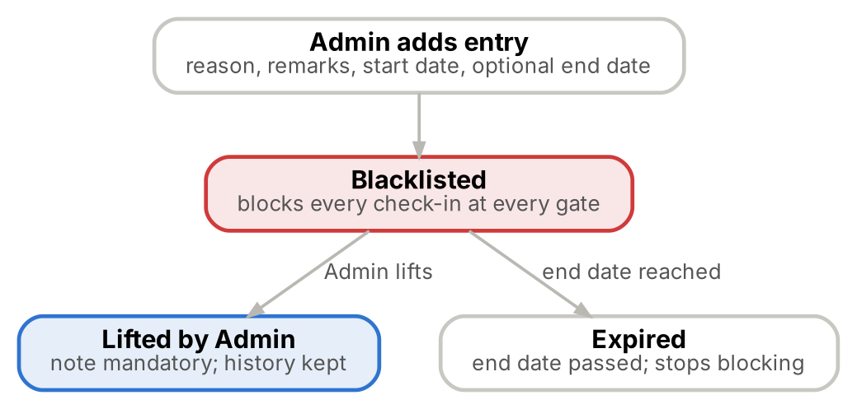
Figure 17. Blacklist lifecycle

22. Reports Module
Six reports page on screen, follow role permissions and mask mobile and ID numbers for users without full access. Report export is limited to Super Admin and Admin (report.export); Security Personnel have no export. Exports are produced in Excel and CSV formats.
Report | Filters | Columns | Export in MVP
Registration (Person) report | Category, status, department, registered date range | Person ID, name, category, mobile, status, registered by, date | Later phase
Visit History report | Name or mobile, category, date range, gate, location | Person, mobile, category, date, gate, location, event (in/out), by, device, accompanying members | Excel and CSV
Occupancy report | Date, location | Date, location, check-ins, check-outs, peak inside, open at day end | Later phase
Staff report | Department, job role, status | Person ID, name, department, job role, shift, joining date | Later phase
Pending Approval report | Category, status, submitted date range | Person ID, name, category, submitted by, date, decision, decided by | Later phase
Blacklist report | Reason, date range, active or expired | Person, reason, start, end, added by, lifted by | Later phase

A Visit History export with a one-month date range is the monthly in/out movement report.

23. Notification Requirements
All notifications in the MVP are in-app. The bell icon shows the unread count; users can mark one or all of their own notifications as read, and can never read or change another user’s notifications. Notifications are kept for 30 days. SMS, WhatsApp and Email notifications are excluded from Phase 1 because of their recurring operational cost.
Event | Recipients | Channel
Registration submitted (Staff, Parivar Member) | Super Admins and Admins with approval authority | In-app
Registration approved | Submitter | In-app
Registration rejected | Submitter, with reason | In-app
Blacklisted person scanned | Guard on screen; Admins and Security Head | In-app, immediate
Blacklisted person currently inside | Admins and Security Head | In-app, immediate
Overstay beyond cut-off | Admins and Security Head | In-app

24. Audit Log Module

24.1 Activities tracked
Module | Activities audited
Security | Login, logout, failed login attempts, lockout, create password, change password, password reset
User management | User creation, update, deletion, activation and deactivation; role and permission changes
Registration | Create, edit, deactivate, reactivate; mobile number, email, passport, category and location changes; location assignment
Approval | Approve, reject, resubmit
QR | Generate, regenerate, public lookup (masked mobile and result)
Bulk upload | Upload initiated, upload completed, upload errors
Blacklist | Add, edit, lift
Gate | Check-in, check-out, gate movement, blocked attempt, location warning
Occupancy | Admin closes or corrects an open visit
Reports | Export
Administration | Master data changes, including category create, update and delete, permission levels and location access rights

24.2 Audit information stored
Field | Description
Changed by (user name and role) | Who performed the action
Activity performed | For example Approve, Check-in
Module | Registration, Approval, Gate and so on
Entity and ID | Record affected
Date and time | Server time, IST
Old value | Changed fields only
New value | Changed fields only
IP and device | Where the action came from
Outcome | Success, blocked or refused, where applicable
Reason | Mandatory reason or note for deactivation, rejection, blacklist, reconciliation and override

24.3 Rules
ID | Requirement
FR-AUD-01 | Super Admin views all audit entries; Admin views operational logs as authorised; Security Personnel view their own gate actions, if enabled. Filter by date, user, module, action and entity; the detail view shows previous and new values side by side.
FR-AUD-02 | Audit entries cannot be edited or deleted through any screen or API; a database trigger rejects update and delete.
FR-AUD-03 | Passwords, tokens and full ID numbers are never written to the audit log.
FR-AUD-04 | Audit entries are retained for the period set in the data retention policy.
FR-AUD-05 | Every data modification is logged with activity performed, old value, new value, changed by, date and time, IP and device.
FR-AUD-06 | Admin exports all audit entries that match the filters to CSV and prints them.
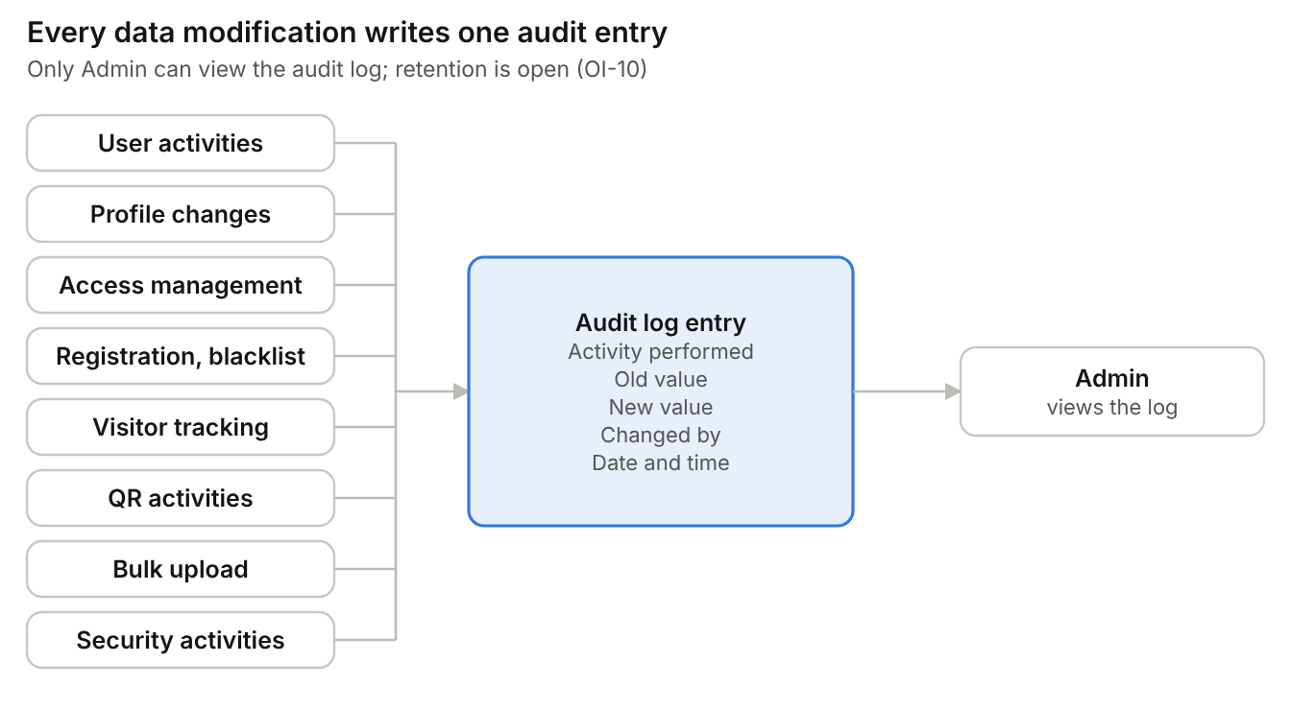
Figure 18. Audit events and audit entry attributes

25. Error Messages
Code | Scenario | Message
MSG-SEC-01 | Invalid login (any reason) | Invalid username or password.
MSG-SEC-02 | Account locked | Too many attempts. Try again in 15 minutes or contact your administrator.
MSG-SEC-03 | Temporary password issued | Temporary password for [username]: [password]. Valid until [date time]. It is shown only once.
MSG-SEC-04 | Session expiring | You will be signed out in 1 minute. Stay signed in?
MSG-SEC-05 | Password change required | Set a new password to continue.
MSG-SEC-06 | Current password wrong | Current password is incorrect.
MSG-SEC-07 | Passwords differ | New password and confirm password do not match.
MSG-SEC-08 | Same password | New password must be different from the old password.
MSG-SEC-09 | Password changed | Password changed. Please sign in with your new password.
MSG-SEC-10 | Login rate limit | Too many sign-in attempts. Try again later.
MSG-SEC-11 | Password issue failed | User created, but the temporary password could not be issued. Issue it from the user list.
MSG-SEC-12 | Not permitted | You do not have permission for this action.
MSG-REG-01 | Mobile already has registrations | This mobile number already has [n] registration(s): [list]. You can continue.
MSG-REG-02 | Photo invalid | Choose a JPG or PNG image no larger than 2 MB.
MSG-REG-03 | Name invalid | Use letters, spaces and hyphens only (1 to 100 characters).
MSG-REG-04 | Saved | [Name] registered as [Person ID]. QR generated. / QR will be generated after approval.
MSG-REG-05 | Empty search | Enter a Person ID, mobile number or name.
MSG-REG-06 | No results | No records found.
MSG-REG-07 | Category not permitted | Your role cannot register this category.
MSG-REG-08 | Passport missing | Passport number is required for Non-Resident / International persons.
MSG-REG-09 | Consent missing | Consent is required before submitting.
MSG-REG-10 | Approval rule not set | The approval rule for this category is not confirmed. Contact your administrator.
MSG-REG-11 | Category changed | This category’s settings changed. Reload the form and review before submitting.
MSG-REG-12 | Document invalid | Attach PDF, JPG or PNG files only, up to 5 MB each and 12 in total.
MSG-APR-01 | Short rejection reason | Rejection reason must be at least 10 characters.
MSG-APR-02 | Self-approval | You cannot approve a registration you submitted.
MSG-APR-03 | Already decided | This registration has already been decided. Refresh the queue.
MSG-QR-01 | Public lookup miss | No active registration found for this number.
MSG-QR-02 | Lookup rate limit | Too many searches. Please try again in a few minutes.
MSG-GATE-01 | Invalid QR | Invalid or replaced QR code. Search by mobile number.
MSG-GATE-02 | Person not found | Registration required.
MSG-GATE-03 | Blacklisted person | BLACKLISTED PERSON — ENTRY NOT ALLOWED. Security has been alerted.
MSG-GATE-04 | Not active | Approval required. / Registration rejected. / Profile deactivated.
MSG-GATE-05 | Access expired | Access expired on [date].
MSG-GATE-06 | Duplicate check-in | Person already inside since [time] at [point]. Check out first.
MSG-GATE-07 | No check-in found | No active check-in found.
MSG-GATE-08 | Location not assigned | Not assigned to [location]. Refuse entry, or acknowledge the override to continue (it will be recorded).
MSG-GATE-09 | Location inactive | Select an active gate and area.
MSG-BL-01 | Bad dates | End date cannot be before start date.
MSG-BL-02 | Duplicate blacklist | This person is already blacklisted.
MSG-OCC-01 | Reconciliation note missing | Enter a note (1 to 500 characters) to close this visit.

26. Complete Business Flow
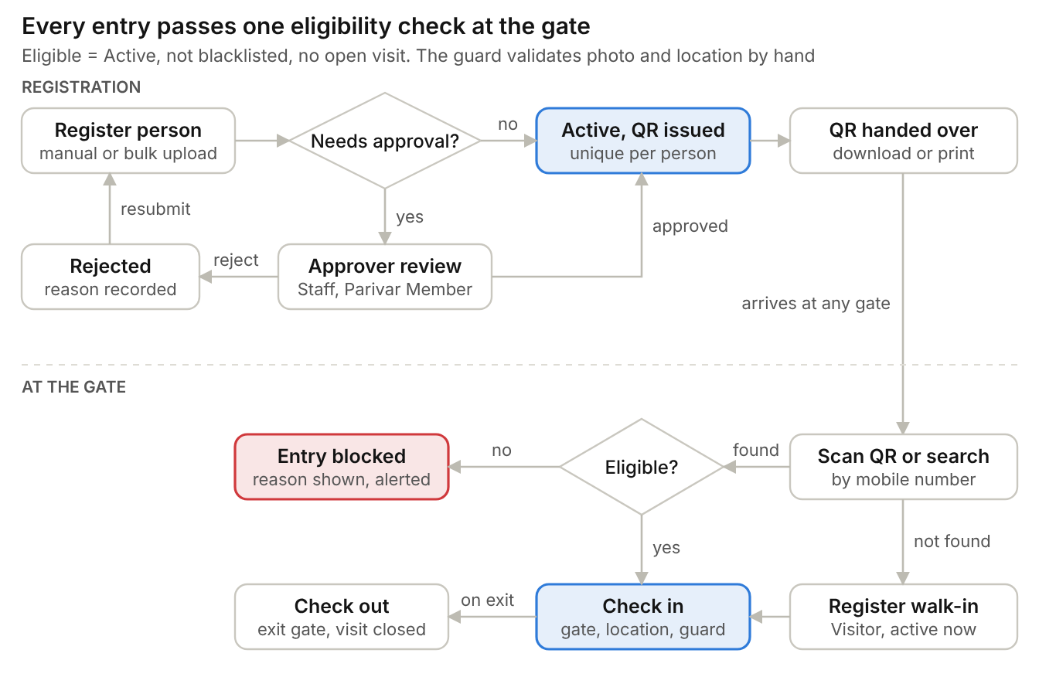
Figure 19. Complete business flow, registration to exit
Step | Actor | Action | Result
1 | IT team / Super Admin / Admin | IT adds the first Super Admin; Super Admin adds Admins and assigns roles; administrators set up master data, categories, gates and areas; each user receives a temporary password and sets a permanent one at first sign-in | System ready for use
2 | Admin | Register person with photo, consent, resident status and assigned areas, or bulk upload a file | Registration saved
3 | System | Apply the category approval rule | Approval Yes → Pending; No → Active; Not set → blocked
4 | Admin with approval authority | Approve or reject Pending registration (never their own) | Active, or Rejected (edit and resubmit)
5 | System | Generate QR for Active registration | QR available
6 | Person | Download QR from public lookup page by mobile number, or collect printed QR at front desk | Person holds QR
7 | Security Personnel | Scan QR or search by mobile, name or Person ID at any gate | Profile shown
8 | System | Eligibility check: QR valid, not blacklisted, Active, access not expired, not already inside; assigned locations shown | Allowed or blocked with reason
9 | Security Personnel | Validate person against photo; refuse or acknowledge a restricted-area warning; check in. If not found, register a walk-in Visitor, then check in | Visit open; occupancy updated
10 | System | Monitor open visits against category cut-off | Overstay alert if still inside
11 | Security Personnel | Check out at any gate; gate and location recorded | Visit completed

27. Assumptions
The system is built on the following assumptions.
Area | Assumption
Gate verification platform | Responsive web application on phone or tablet; native app in a later phase
Approval rule | Approval required flag in Category master (Yes, No or Not set); seeded Yes for Staff and Parivar Member; Not set blocks registration
Photo capture method | Camera capture allowed
Accompanying members in occupancy | Accompanying members recorded at check-in are added to the occupancy count
Overstay cut-off and alert recipients | 10:00 PM for day visitors and contractors; other categories set in Category master; Admins and Security Head receive alerts
Manual register entries after downtime | Entries stay on paper; Admin may later load them through bulk upload
Blacklist end date | Optional end date; blank means indefinite
Non-Resident / International mobile numbers | 10-digit Indian mobile required; Passport Number mandatory for Non-Resident / International
Visit History export format | Excel and CSV
Data retention and DPDP | DPDP compliance applies; retention periods are set by Ashram Management
Scale and sizing | Indicative: 1000+ person records, 500 concurrent users
Access-control hardware | None planned; location and gate access is monitored manually by Security
OTP, SMS, WhatsApp, Email | Excluded from Phase 1 due to recurring operational cost
Bulk upload template | Template downloadable from the Bulk Upload screen
Category mapping | Seed categories map to the broad categories Volunteer, Active Member and Visitor as agreed with Ashram Management
Role model | four RBAC roles (Super Admin, Admin, Security Personnel, User) with a permission matrix
Portal user onboarding | administrator-issued temporary password and forced change at first sign-in; no OTP, email or SMS delivery
File storage | Photos and documents are stored privately in S3 object storage and scanned for malware
Technology baseline | React and Vite responsive web client; Node.js 22 and Express API under /api/v1; PostgreSQL 16 (schema mams) with ordered migrations

28. Technical, Security and Data Protection Requirements

28.1 Common behaviour
ID | Requirement
FR-TEC-01 | The client calls a versioned API under /api/v1 and attaches the bearer token held in memory; a 401 response ends the session.
FR-TEC-02 | The API exposes GET /health returning status ok.
FR-TEC-03 | The API applies JSON size limits, an exact allowed origin (CORS), security headers, request logging, not-found handling and central error responses.
FR-TEC-04 | Every request payload is validated; invalid input returns an explicit client error and is never saved as a success.
FR-TEC-05 | All database access uses parameterised queries; related writes use transactions.
FR-TEC-06 | Schema changes are delivered as new, checksum-tracked migrations; applied migrations are never edited.

28.2 API route groups
Route group (/api/v1) | Function
/auth | Login, logout, password change
/users | User list, create, detail, password reset, deactivation, permission flags
/categories, /lookups, /locations | Category and form schema, master values, gates and areas
/persons | Registration options, drafts, profile, photo and documents, access, status
/approvals | Approval queue, decisions, resubmission
/public | Public QR lookup
/gate, /visits | Gate lookup; check-in, check-out, reconciliation
/blacklist | List, add, lift
/dashboard, /reports | Dashboard summaries and occupancy; six reports
Activity routes | User notifications; audit browsing

28.3 Data protection
ID | Requirement
FR-DP-01 | Passwords are stored only as bcrypt hashes; no plain-text password is stored or logged.
FR-DP-02 | Passport and ID numbers are encrypted with AES-256-GCM (fresh nonce per value) before storage and omitted from ordinary profile responses.
FR-DP-03 | Photos and documents are stored outside any public folder under random file keys and served only after checking the user’s permission and the file’s link to the person; responses are private and not cached.
FR-DP-04 | Mobile numbers are masked in gate results, public lookup results and lookup logs.
FR-DP-05 | Production uses separate high-entropy JWT and QR signing secrets, a stable encryption key, database TLS, an exact UI origin and a configured trusted-proxy count; secrets are never committed or exposed to the browser.
FR-DP-06 | Uploads are scanned for malware and stored in private S3 object storage; retention is automated and encryption keys can be rotated.
FR-DP-07 | The system complies with the Digital Personal Data Protection (DPDP) Act requirements agreed with the business.

28.4 Non-functional and operational requirements
ID | Requirement
NFR-01 | Search result in 3 seconds or less; QR scan response in 2 seconds or less; dashboard in 5 seconds or less.
NFR-02 | API runs on Node.js 22 or later with PostgreSQL 16.
NFR-03 | Production API refuses to start without an explicit trusted-proxy count.
NFR-05 | Offline gate operation follows the paper-register procedure because there is no software queue.
NFR-06 | Camera scanning and torch work on the phones and tablets used at the gates.

